TONE COLOUR VOCABULARY
 | Bright, Glittering, Brilliant, Clear, Sparkling, Shimmering, Silvery, Pure
 | Mellow, Warm, Sweet, Resonant, Rich, Smooth, Tranquil
 | Distorted, Aggressive, Coarse, Dark, Muddy, Shrill, Abrasive, Screeching
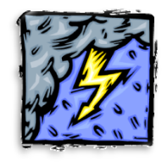 | Powerful, Grand, Strong, Booming, Ringing
 | Breathy, Hollow, Airy, Muffled, Muted, Breathy, Light
 | Artificial, Synthetic, Electronic, Futuristic, Buzzing, Beeping, Digital
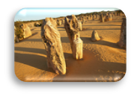 | Dry, Scratchy, Bland, Hollow, Rough
 | Nasal, Haunting, Sombre, Murky, Reedy, Thin, Eerie
 | Piercing, Metallic, Brassy, Blaring, Blazing

