
Year 1/2 Mini Melodies
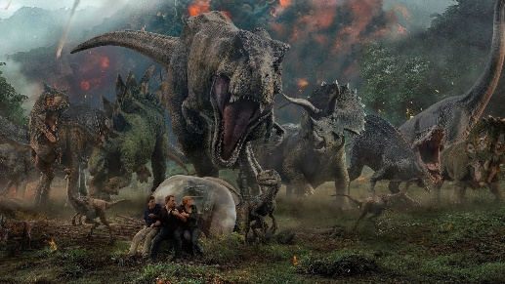
Jurassic Park
Theme

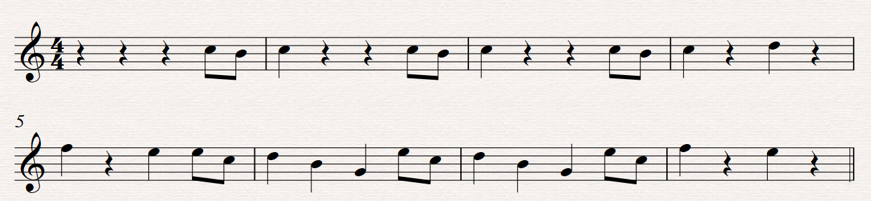
Main Theme Melody:

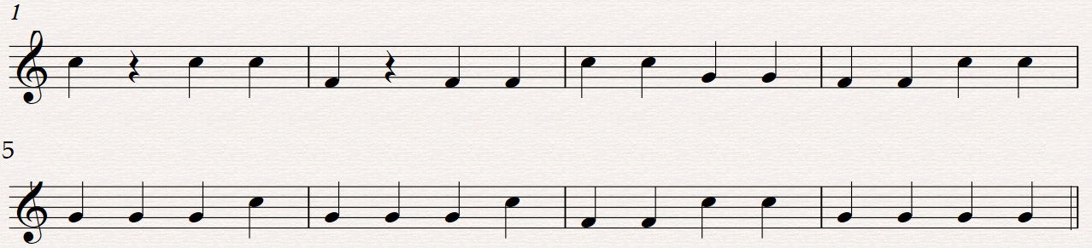
Accompaniment:
