“Kids” – MGMT Melody

Melody
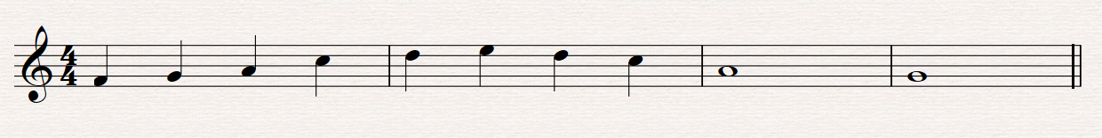

Bass

