David Guetta feat. Sia - Titanium
Guitar Page 1

Intro/Verse

G
Am
C
Am

Intro 1+2+3+4+ 1+2+3+4+ 1+2+3+4+ 1+2+3+4+
Verse 1+2+3+4+ 1+2+3+4+ 1+2+3+4+ 1+2+3+4+

David Guetta feat. Sia - Titanium
Guitar Page 2

Chorus/Instrumental/Bridge
Em
G
Am
F

Chorus/Bridge 1+2+3+4+ 1+2+3+4+ 1+2+3+4+ 1+2+3+4+
Instrumental 1+2+3+4+ 1+2+3+4+ 1+2+3+4+ 1+2+3+4+

David Guetta feat. Sia - Titanium
Bass Guitar

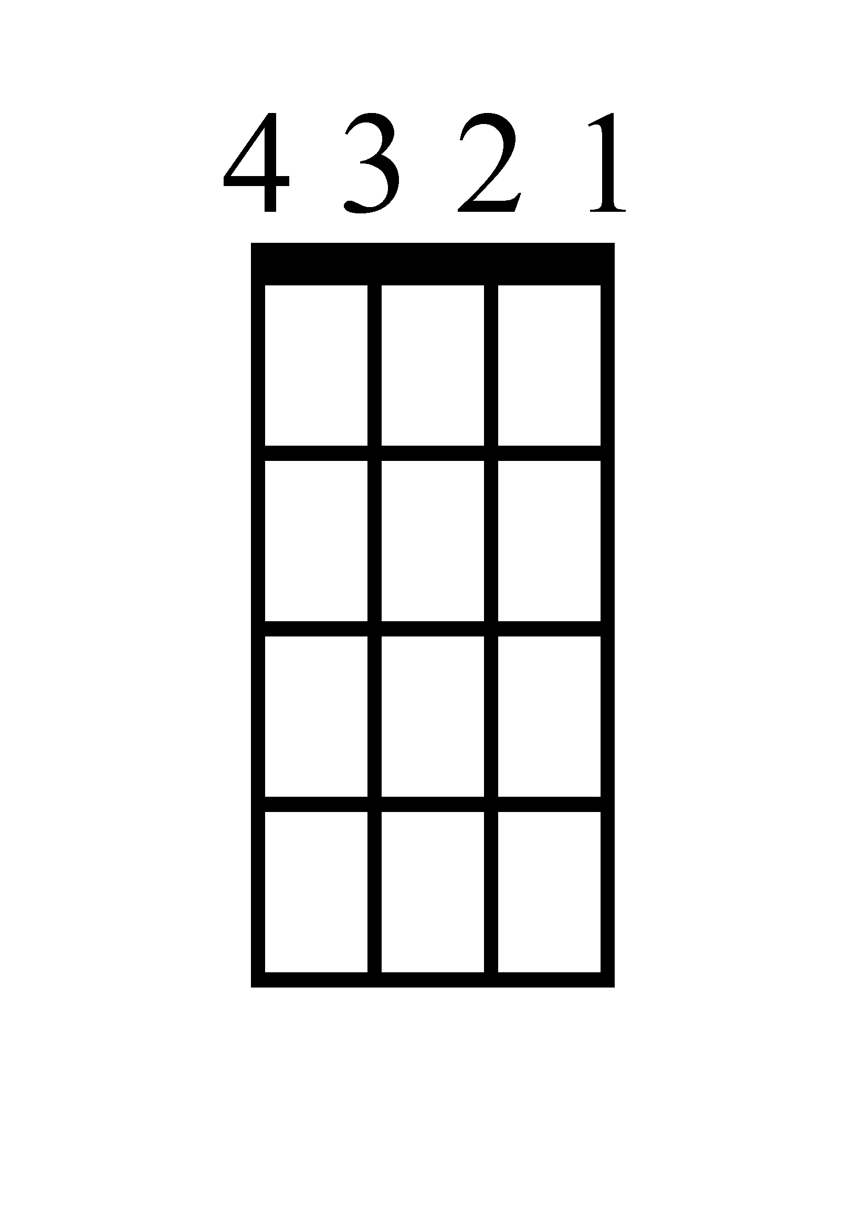
Verse
C
G
Am
Am

Intro 1+2+3+4+ 1+2+3+4+ 1+2+3+4+ 1+2+3+4+
Verse 1+2+3+4+ 1+2+3+4+ 1+2+3+4+ 1+2+3+4+

Chorus/Instrumental/Bridge
F
G
Em
Am

Chorus/Bridge 1+2+3+4+ 1+2+3+4+ 1+2+3+4+ 1+2+3+4+
Instrum. 1+2+3+4+ 1+2+3+4+ 1+2+3+4+ 1+2+3+4+
David Guetta feat. Sia - Titanium
Ukulele
Am
Verse
Am
G
C

Intro 1+2+3+4+ 1+2+3+4+ 1+2+3+4+ 1+2+3+4+
Verse 1+2+3+4+ 1+2+3+4+ 1+2+3+4+ 1+2+3+4+

Chorus/Instrumental/Bridge
Am
Em
G
F

Chorus/Bridge 1+2+3+4+ 1+2+3+4+ 1+2+3+4+ 1+2+3+4+
Instrum. 1+2+3+4+ 1+2+3+4+ 1+2+3+4+ 1+2+3+4+

David Guetta feat. Sia - Titanium
Piano Page 1
C G Am Am
Intro 1+2+3+4+ 1+2+3+4+ 1+2+3+4+ 1+2+3+4+
Verse 1+2+3+4+ 1+2+3+4+ 1+2+3+4+ 1+2+3+4+

Verse
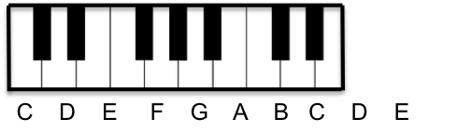
C

G

Am

Am
David Guetta feat. Sia - Titanium
Piano Page 2

Chorus/Instrumental/Bridge
F G Em Am
Chorus/Bridge 1+2+3+4+ 1+2+3+4+ 1+2+3+4+ 1+2+3+4+
Intrum. 1+2+3+4+ 1+2+3+4+ 1+2+3+4+ 1+2+3+4+

F

G

Em
Am
David Guetta feat. Sia - Titanium
Lyrics Page 1

Verse 1
You shout it out
But I can't hear a word you say
I'm talking loud not saying much
I'm criticized but all your bullets ricochet
You shoot me down, but I get up

Chorus 1
I'm bulletproof nothing to lose
Fire away, fire away
Ricochet, you take your aim
Fire away, fire away
You shoot me down but I won't fall, I am titanium
You shoot me down but I won't fall
I am titanium, I am titanium, I am titanium, I am titanium

Verse 2
Cut me down
But it's you who has further to fall
Ghost town, haunted love
Raise your voice, sticks and stones may break my bones
I'm talking loud not saying much

David Guetta feat. Sia - Titanium
Lyrics Page 2

Chorus 2
I'm bulletproof nothing to lose
Fire away, fire away
Ricochet, you take your aim
Fire away, fire away
You shoot me down but I won't fall
I am titanium
You shoot me down but I won't fall
I am titanium, I am titanium

Bridge
Stone-hard, machine gun
Firing at the ones who run
Stone-hard, thus bulletproof glass

Chorus
You shoot me down but I won't fall, I am titanium
You shoot me down but I won't fall, I am titanium
You shoot me down but I won't fall, I am titanium
You shoot me down but I won't fall, I am titanium
I am titanium

