Imagine Dragons - Thunder
Bass Guitar

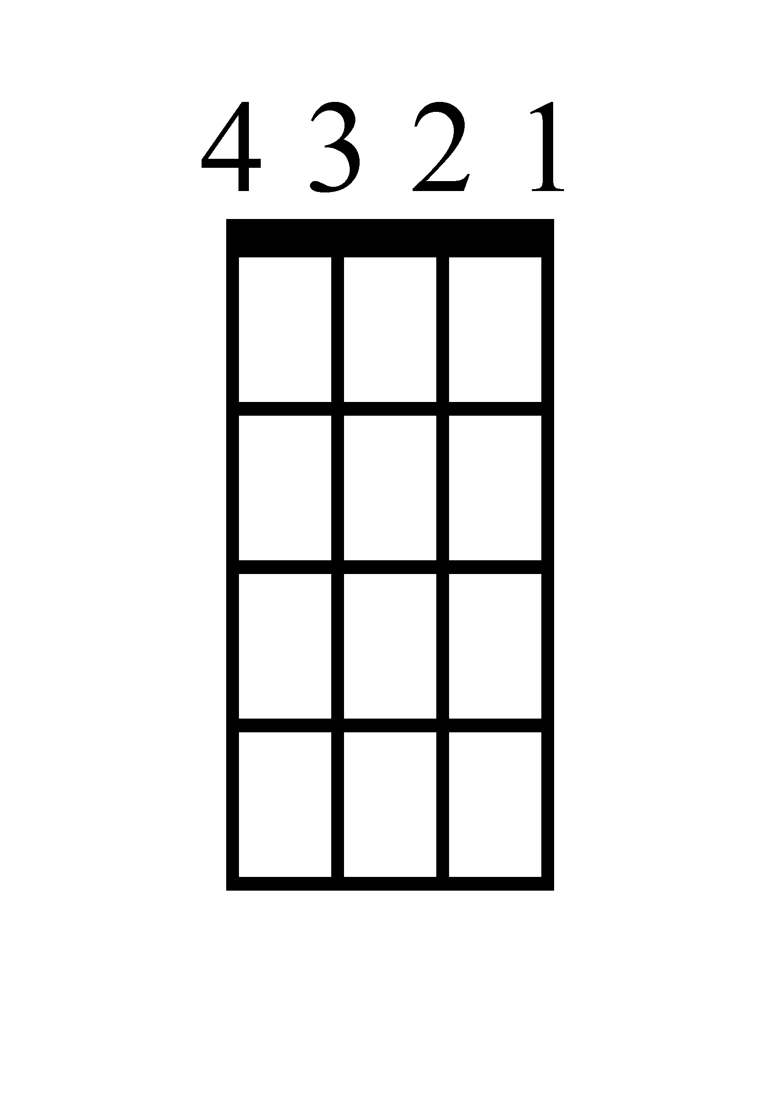
Verse
F
C

8 times! 8 times!
Chorus
F
Am
C

8 times! 4 times! 4 times!
Imagine Dragons - Thunder
Ukulele

Verse
F
C

8 times! 8 times!
Chorus
F
Am
C

8 times! 4 times! 4 times!

Imagine Dragons - Thunder
Piano

Verse

C

F

Chorus
C

Am

F

Imagine Dragons - Thunder
Lyrics

[Verse 1]
Just a young gun with a quick fuse
I was uptight, wanna let loose
I was dreaming of bigger things
And wanna leave my old life behind
Not a yessir, not a follower
Fit the box, fit the mold
Have a seat in the foyer, take a number
I was lightning before the thunder

[Chorus]
Thunder, feel the thunder
Lightning then the thunder
Thunder, feel the thunder
Lightning then the thunder
Thunder, thunder
Thunder

[Verse 2]
Kids were laughing in my classes
While I was scheming for the masses
Who do you think you are?
Dreaming 'bout being a big star
They say you're basic, they say you're easy
You're always riding in the backseat
Now I'm smiling from the stage
While you were clapping in the far seats

[Chorus]
Thunder, feel the thunder
Lightning then the thunder
Thunder, feel the thunder
Lightning then the thunder
Thunder

[Bridge]
Thunder, feel the thunder
Lightning then the thunder, thunder

[Chorus]
Thunder, feel the thunder
Lightning then the thunder, thunder
Thunder, feel the thunder
Lightning then the thunder, thunder
Thunder, feel the thunder
Lightning then the thunder, thunder
Thunder, feel the thunder
Lightning then the thunder, thunder

