Shawn Mendez – There’s Nothing Holding Me Back
Guitar Chords
A
Bm
A
G

Verse 1+2+3+4+ 1+2+3+4+ 1+2+3+4+ 1+2+3+4+
Pre-Chorus 1+2+3+4+ 1+2+3+4+ 1+2+3+4+ 1+2+3+4+
Chorus 1+2+3+4+ 1+2+3+4+ 1+2+3+4+ 1+2+3+4+

Shawn Mendez – There’s Nothing Holding Me Back
Bass Guitar

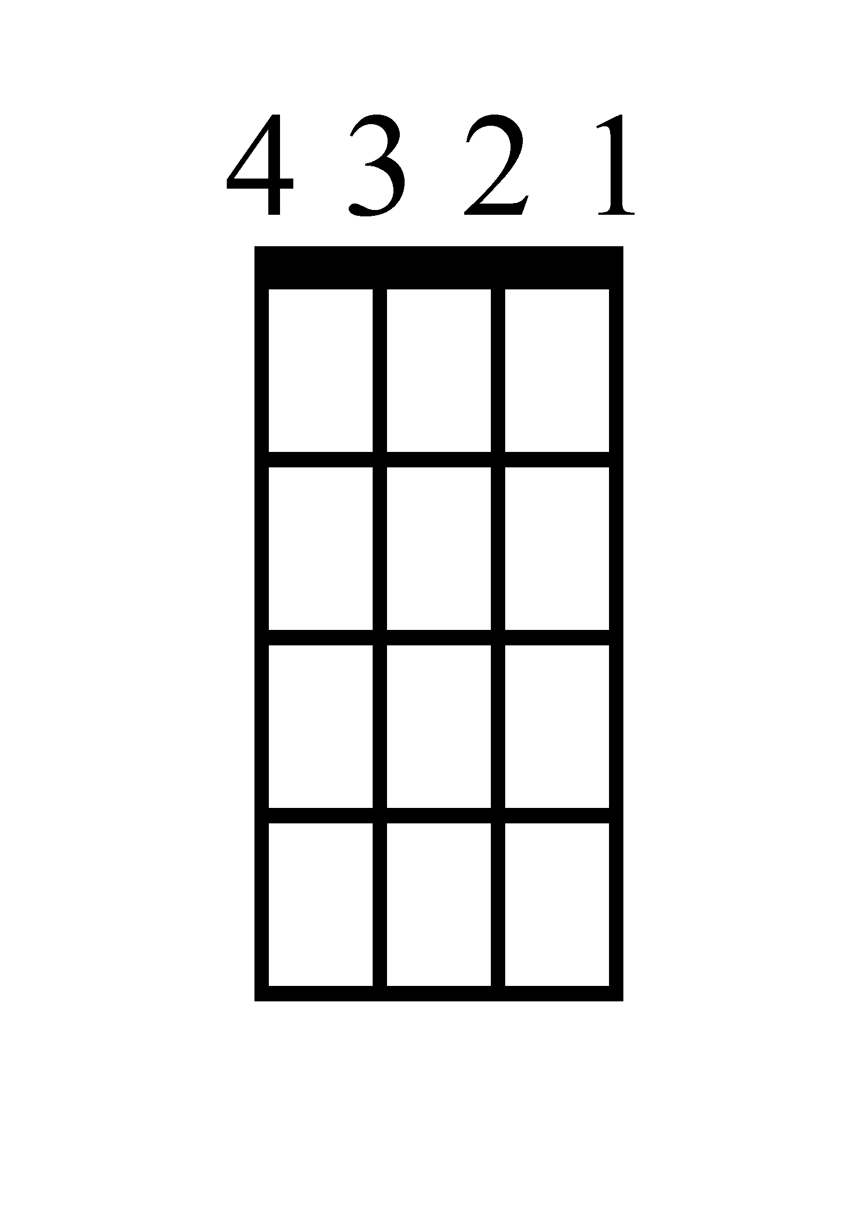
A
A
B
G

Verse 1+2+3+4+ 1+2+3+4+ 1+2+3+4+ 1+2+3+4+
Pre-Chorus 1+2+3+4+ 1+2+3+4+ 1+2+3+4+ 1+2+3+4+
Chorus 1+2+3+4+ 1+2+3+4+ 1+2+3+4+ 1+2+3+4+

Shawn Mendez – There’s Nothing Holding Me Back
Ukulele Chords
A
Bm
A
G

Verse 1+2+3+4+ 1+2+3+4+ 1+2+3+4+ 1+2+3+4+
Pre-Chorus 1+2+3+4+ 1+2+3+4+ 1+2+3+4+ 1+2+3+4+
Chorus 1+2+3+4+ 1+2+3+4+ 1+2+3+4+ 1+2+3+4+

Shawn Mendez – There’s Nothing Holding Me Back
Piano

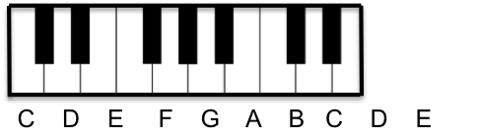
G
V 1+2+3+4+
PC 1+2+3+4+
C 1+2+3+4+

Bm
V 1+2+3+4+
PC 1+2+3+4+
C 1+2+3+4+

A
V 1+2+3+4+
PC 1+2+3+4+
C 1+2+3+4+

A
V 1+2+3+4+
PC 1+2+3+4+
C 1+2+3+4+

Shawn Mendez – There’s Nothing Holding Me Back
Lyrics (Page 1)

[Verse 1]
I wanna follow where she goes
I think about her and she knows it
I wanna let her take control
'Cause everytime that she gets close, yeah

[Pre-Chorus]
She pulls me in enough to keep me guessing
And maybe I should stop and start confessing, confessing, yeah

[Chorus]
Oh, I've been shaking
I love it when you go crazy
You take all my inhibitions
Baby, there's nothing holdin' me back
You take me places that tear up my reputation
Manipulate my decisions
Baby, there's nothing holdin' me back
There's nothing holdin' me back
There's nothing holdin' me back

[Verse 2]
She says that she's never afraid
Just picture everybody naked
She really doesn't like to wait
Not really into hesitation

Shawn Mendez – There’s Nothing Holding Me Back
Lyrics (Page 2)

[Pre-Chorus]
Pulls me in enough to keep me guessing
And maybe I should stop and start confessing, confessing, yeah

[Chorus]
Oh, I've been shaking
I love it when you go crazy
You take all my inhibitions
Baby, there's nothing holding me back
You take me places that tear up my reputation
Manipulate my decisions
Baby, there's nothing holding me back
There's nothing holding me back

[Bridge]
'Cause if we lost our minds and we took it way too far
I know we'd be alright, I know we would be alright
If you were by my side and we stumbled in the dark
I know we'd be alright, I know we would be alright
'Cause if we lost our minds and we took it way too far
I know we'd be alright, I know we would be alright
If you were by my side and we stumbled in the dark
I know we'd be alright, we would be alright

Shawn Mendez – There’s Nothing Holding Me Back
Lyrics (Page 3)

[Chorus]
Oh, I've been shaking
I love it when you go crazy
You take all my inhibitions
Baby, there's nothing holdin' me back
You take me places that tear up my reputation
Manipulate my decisions
Baby, there's nothing holdin' me back
There's nothing holding me back
I feel so free when you're with me, baby
Baby, there's nothing holdin' me back

