Ava Max – Sweet But Psycho
Guitar

G
Am
G
C
F

Intro 1+2+3+4+ 1+2+3+4+ 1+2+3+4+ 1+2+ 3+4+
Verse 1+2+3+4+ 1+2+3+4+ 1+2+3+4+ 1+2+ 3+4+
Chorus 1+2+3+4+ 1+2+3+4+ 1+2+3+4+ 1+2+ 3+4+

Ava Max – Sweet But Psycho
Bass Guitar

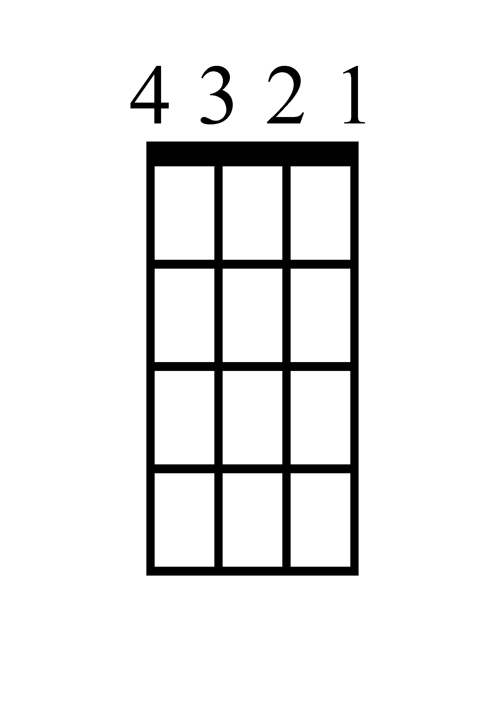
A
G
F
C
G

Intro 1+2+3+4+ 1+2+3+4+ 1+2+3+4+ 1+2+ 3+4+
Verse 1+2+3+4+ 1+2+3+4+ 1+2+3+4+ 1+2+ 3+4+
Chorus 1+2+3+4+ 1+2+3+4+ 1+2+3+4+ 1+2+ 3+4+

Ava Max – Sweet But Psycho
Ukulele

F
C
G
Am
G

Intro 1+2+3+4+ 1+2+3+4+ 1+2+3+4+ 1+2+ 3+4+
Verse 1+2+3+4+ 1+2+3+4+ 1+2+3+4+ 1+2+ 3+4+
Chorus 1+2+3+4+ 1+2+3+4+ 1+2+3+4+ 1+2+ 3+4+

Ava Max – Sweet But Psycho
F C G Am G
Intro 1+2+3+4+ 1+2+3+4+ 1+2+3+4+ 1+2+ 3+4+
Verse 1+2+3+4+ 1+2+3+4+ 1+2+3+4+ 1+2+ 3+4+
Chorus 1+2+3+4+ 1+2+3+4+ 1+2+3+4+ 1+2+ 3+4+

Piano

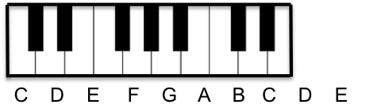
F

C

G

Am

G

Ava Max – Sweet But Psycho
Lyrics (Page 1)

Chorus 1
Oh, she's sweet but a psycho
A little bit psycho
At night she's screamin', "I'm-ma-ma-ma out my mind."
Oh, she's hot but a psycho
So left but she's right though
At night she's screamin', "I'm-ma-ma-ma out my mind."

Verse 1
She'll make you curse, but she a blessing
She'll rip your shirt within a second
You'll be coming back, back for seconds
With your plate, you just can't help it

Pre-Chorus 1
No, no
You'll play along,
Let her lead you on
You'll be thinking, "No, no"
Then saying, "Yes, yes, yes,"
'Cause she messin' with your head

Chorus 2
Oh, she's sweet but a psycho
A little bit psycho
At night she's screamin', "I'm-ma-ma-ma out my mind."
Oh, she's hot but a psycho
So left but she's right though
At night she's screamin', "I'm-ma-ma-ma out my mind."
Ava Max – Sweet But Psycho
Lyrics (Page 2)

Verse 2 Continued
Grab a cop gun. Kinda crazy
She's poison but tasty
Yeah, people say, "Run, don't walk away,"
'Cause she's sweet but a psycho
A little bit psycho
At night she's screamin', "I'm-ma-ma-ma out my mind."

Verse 2
See, someone said, "Don't drink her potions
She'll kiss your neck with no emotions
When she's mean, you know you love it
She tastes so sweet. Don't sugarcoat it."

Pre-Chorus 2
No, no
You'll play along,
Let her lead you on
You'll be thinking, "No (No, no, no), no (No)."
Then saying, "Yes, yes, yes,"
'Cause she messin' with your head

Chorus 3
Oh, she's sweet but a psycho
A little bit psycho
At night she's screamin', "I'm-ma-ma-ma out my mind."
Oh, she's hot but a psycho
So left but she's right though
At night she's screamin', "I'm-ma-ma-ma out my mind."
Ava Max – Sweet But Psycho
Lyrics (Page 3)

Chorus 3 Continued
Grab a cop gun. Kinda crazy
She's poison but tasty
Yeah, people say, "Run, don't walk away,"
'Cause she's sweet but a psycho
A little bit psycho
At night she's screamin', "I'm-ma-ma-ma out my mind."

Breakdown!

Verse 3 - Breakdown
You're just like me, you're out your mind
I know it's strange. We're both the crazy kind
You're tellin' me that I'm insane
Boy, don't pretend that you don't love the pain

Chorus 4
Oh, she's sweet but a psycho
A little bit psycho
At night she's screamin', "I'm-ma-ma-ma out my mind."
Oh, she's hot but a psycho
So left but she's right though
At night she's screamin', "I'm-ma-ma-ma out my mind."
Grab a cop gun. Kinda crazy
She's poison but tasty
Yeah, people say, "Run, don't walk away,"
Oh, she's sweet but a psycho
A little bit psycho
At night she's screamin', "I'm-ma-ma-ma out my mind."

