Post Malone & Swae Lee - Sunflower
Guitar

Em
G
G
D

1+2+3+4+ x2 1+2+3+4+ x2 1+2+3+4+ x2 1+2+3+4+ x2

Post Malone & Swae Lee - Sunflower
Bass Guitar

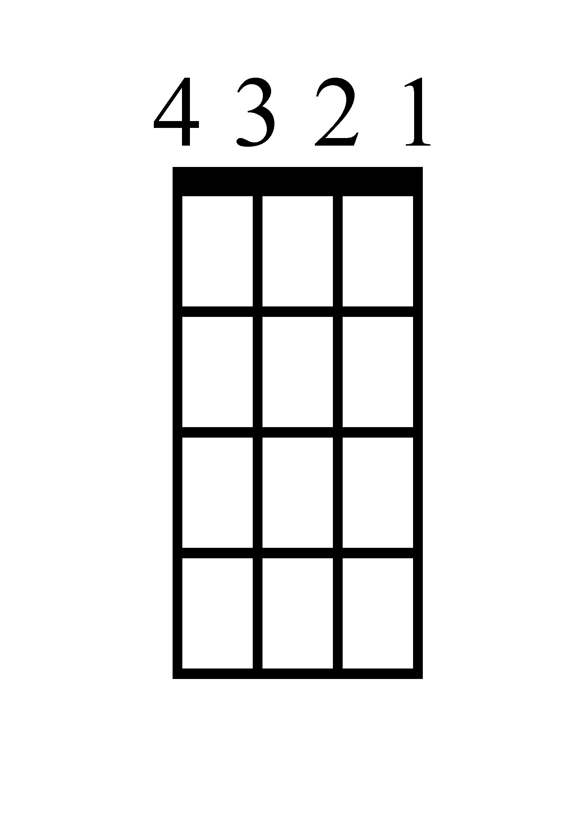
D
G
Em
G

1+2+3+4+ x2 1+2+3+4+ x2 1+2+3+4+ x2 1+2+3+4+ x2

Post Malone & Swae Lee - Sunflower
Ukulele
Em
D
G
G

1+2+3+4+ x2 1+2+3+4+ x2 1+2+3+4+ x2 1+2+3+4+ x2

Post Malone & Swae Lee - Sunflower
Piano

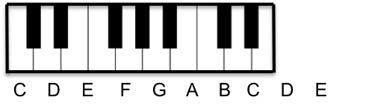
D
1+2+3+4+ x2 1+2+3+4+ x2 1+2+3+4+ x2 1+2+3+4+ x2

G
1+2+3+4+ x2 1+2+3+4+ x2 1+2+3+4+ x2 1+2+3+4+ x2

Em
1+2+3+4+ x2 1+2+3+4+ x2 1+2+3+4+ x2 1+2+3+4+ x2

G
1+2+3+4+ x2 1+2+3+4+ x2 1+2+3+4+ x2 1+2+3+4+ x2

Post Malone & Swae Lee - Sunflower
Lyrics (Page 1)

Intro
Ayy, ayy, ayy, ayy (ooh)
Ooh, ooh, ooh, ohh (ooh)
Ayy, ayy
Ooh, ooh, ooh, ohh

Verse 1
Needless to say, I keep a check
She was all bad-bad, nevertheless (yeah)
Callin' it quits now, baby, I'm a wreck (wreck)
Crash at my place, baby, you're a wreck (wreck)

Verse 2
Needless to say, I'm keepin' our check
She was all bad-bad, nevertheless
Callin' it quits now, baby, I'm a wreck
Crash at my place, baby, you're a wreck

Verse 3
Thinkin' in a bad way, losin' your grip
Screamin' at my face, baby, don't trip
Someone took a big L, don't know how that felt
Lookin' at you sideways, party on tilt

Pre-Chorus 1
Ooh-ooh
Some things you just can't refuse
She wanna ride like a cruise
And I'm not tryna lose

Chorus 1
Then you're left in the dust
Unless I stuck by ya
You're a sunflower
I think your love would be too much
Or you'll be left in the dust
Unless I stuck by ya
You're the sunflower
You're the sunflower

Verse 4
Every time I'm leavin' on you
You don't make it easy, no, no
Wish I could be there for you
Give me a reason to go

Verse 5
Every time I'm walkin' out
I can hear you tellin' me to turn around
Fightin' for my trust and you won't back down
Even if we gotta risk it all right now, oh

Verse 6
I know you're scared of the unknown (-known)
You don't wanna be alone (alone)
I know I always come and go (and go)
But it's out of my control

Chorus 2
And you'll be left in the dust
Unless I stuck by ya
You're the sunflower
I think your love would be too much
Or you'll be left in the dust
Unless I stuck by ya
You're the sunflower
You're the sunflower
Yeah

