The Chainsmokers and Coldplay – Something Just Like This
Guitar Chords
A
A
Bm
G

1+2+3+4+ 1+2+3+4+ 1+2+3+4+ 1+2+3+4+
1+2+3+4+ 1+2+3+4+ 1+2+3+4+ 1+2+3+4+
D
Outro last chord!

The Chainsmokers and Coldplay – Something Just Like This
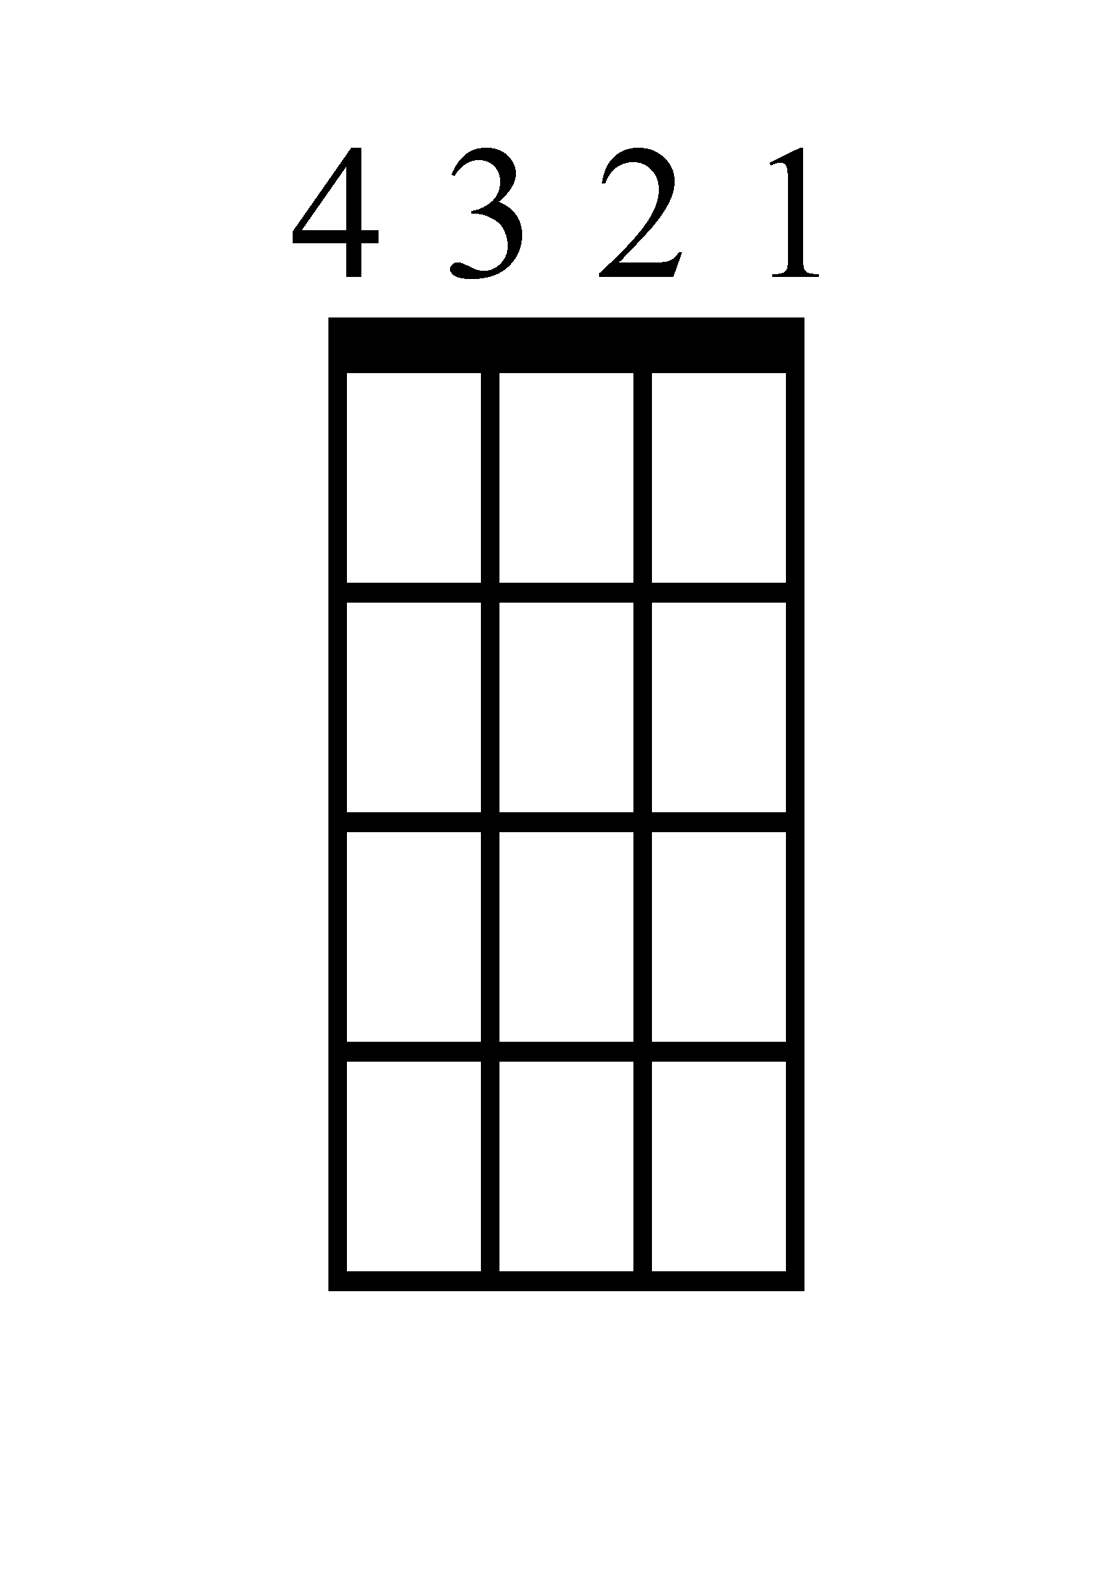
Bass Guitar
A
B
A
G

1+2+3+4+ 1+2+3+4+ 1+2+3+4+ 1+2+3+4+
1+2+3+4+ 1+2+3+4+ 1+2+3+4+ 1+2+3+4+
D

Outro last note!

The Chainsmokers and Coldplay – Something Just Like This
Ukulele Chords
Bm
A
G
A

1+2+3+4+ 1+2+3+4+ 1+2+3+4+ 1+2+3+4+
1+2+3+4+ 1+2+3+4+ 1+2+3+4+ 1+2+3+4+
D
Outro last chord!

The Chainsmokers and Coldplay – Something Just Like This
Piano

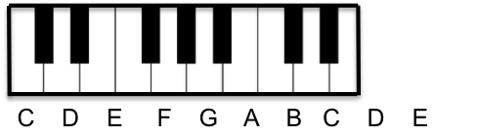
G
1+2+3+4+
1+2+3+4+

A
1+2+3+4+
1+2+3+4+

Bm
1+2+3+4+
1+2+3+4+

A
1+2+3+4+
1+2+3+4+

D
1+2+3+4+
1+2+3+4+

This D chord replaces the last A in the outro!
The Chainsmokers and Coldplay – Something Just Like This
Lyrics (Page 1)

[Verse 1]
I've been reading books of old
The legends and the myths
Achilles and his gold
Hercules and his gifts
Spiderman's control
And Batman with his fists
And clearly I don't see myself upon that list

[Pre-Chorus]
But she said, where'd you wanna go?
How much you wanna risk?
I'm not looking for somebody
With some superhuman gifts
Some superhero
Some fairytale bliss
Just something I can turn to
Somebody I can kiss

[Bridge]
I want something just like this
Doo-doo-doo, doo-doo-doo
Doo-doo-doo, doo-doo
Doo-doo-doo, doo-doo-doo
Oh, I want something just like this
Doo-doo-doo, doo-doo-doo
Doo-doo-doo, doo-doo
Doo-doo-doo, doo-doo-doo
The Chainsmokers and Coldplay – Something Just Like This
Lyrics (Page 2)

[Chorus]
Oh, I want something just like this
I want something just like this

[Verse 2]
I've been reading books of old
The legends and the myths
The testaments they told
The moon and its eclipse
And Superman unrolls
A suit before he lifts
But I'm not the kind of person that it fits

[Pre-Chorus]
She said, where'd you wanna go?
How much you wanna risk?
I'm not looking for somebody
With some superhuman gifts
Some superhero
Some fairytale bliss
Just something I can turn to
Somebody I can miss

[Chorus]
I want something just like this
I want something just like this

The Chainsmokers and Coldplay – Something Just Like This
Lyrics (Page 3)

[Bridge]
Oh, I want something just like this
Doo-doo-doo, doo-doo-doo
Doo-doo-doo, doo-doo
Doo-doo-doo, doo-doo-doo
Oh, I want something just like this
Doo-doo-doo, doo-doo-doo
Doo-doo-doo, doo-doo
Doo-doo-doo, doo-doo-doo

[Pre-Chorus]
Where'd you wanna go?
How much you wanna risk?
I'm not looking for somebody
With some superhuman gifts
Some superhero
Some fairytale bliss
Just something I can turn to
Somebody I can kiss
I want something just like this

[Chorus]
Oh, I want something just like this
Oh, I want something just like this
Oh, I want something just like this

