Magic - Rude
Guitar

F
G
C
Am

Verse/Chorus 1+2+ 3+4+ 1+2+ 3+4+
Pre-Chorus 1+2+ 3+4+ 1+2+ 3+4+
Breakdown! Do do do Do do do Do do do Do do do!

Magic - Rude
Bass Guitar

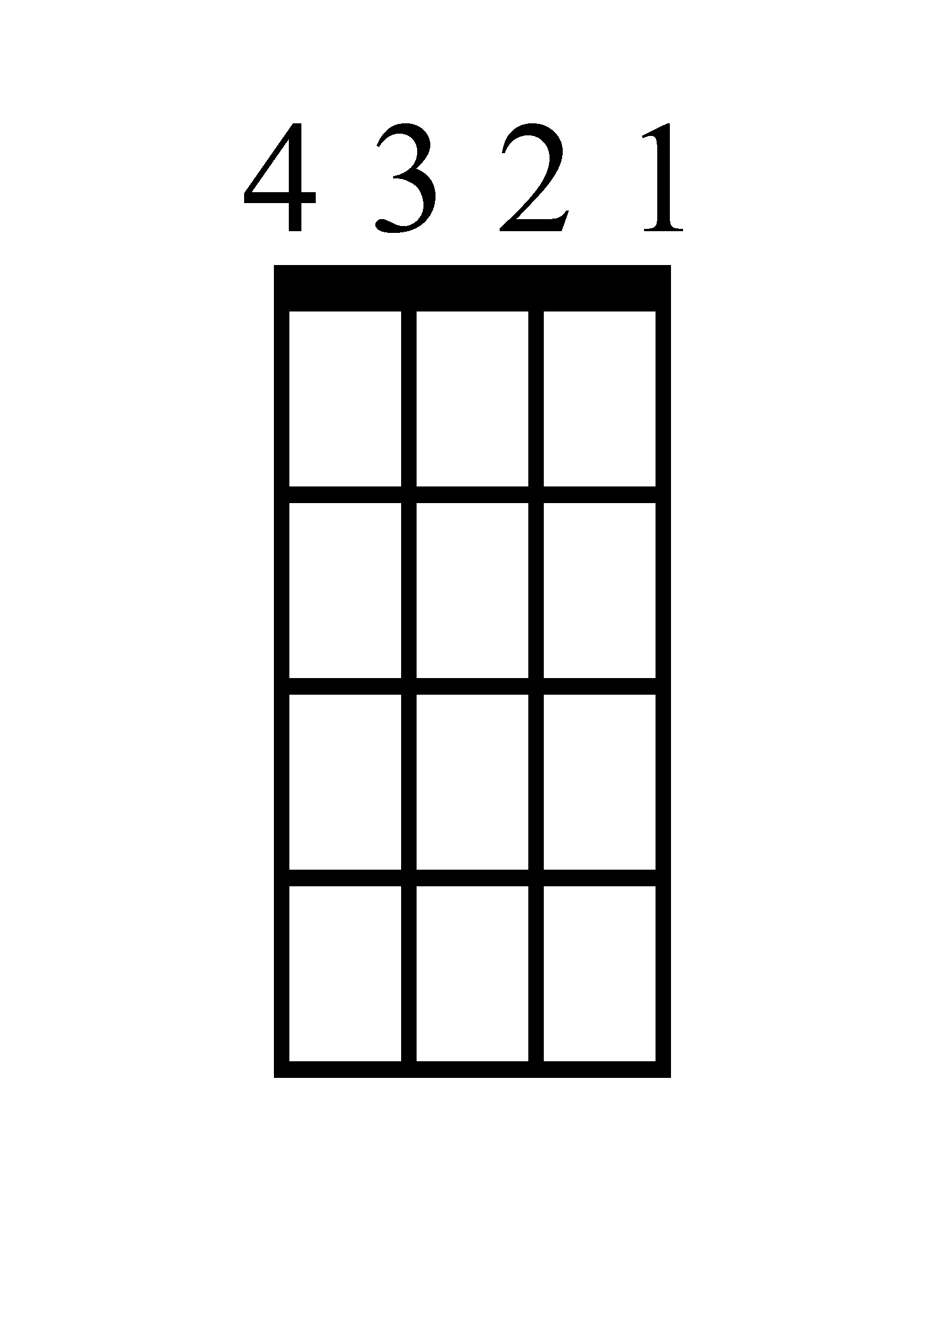
F
C
G
A

Verse/Chorus 1+2+ 3+4+ 1+2+ 3+4+
Pre-Chorus 1+2+ 3+4+ 1+2+ 3+4+
Breakdown! Do do do! Do do do! Do do do! Do do do!

Magic - Rude
Ukulele
Am
G
C
F

D
G
C
Em

Verse/Chorus 1+2+ 3+4+ 1+2+ 3+4+
Pre-Chorus 1+2+ 3+4+ 1+2+ 3+4+
Breakdown! Do do do! Do do do! Do do do! Do do do!

Magic - Rude
Piano
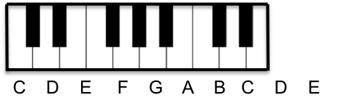
F
F G C Am
Verse/Chorus 1+2+ 3+4+ ` 1+2+ 3+4+
Pre-Chorus 1+2+ 3+4+ 1+2+ 3+4+
Breakdown! Do do do! Do do do! Do do do! Do do do!

G

C

Am

Magic - Rude
Lyrics (Page 1)

Verse 1
Saturday mornin', jumped outta bed and put on my best suit
Got in my car and raced like a jet all the way to you
Knocked on your door with heart in my hand to ask you a question
'Cause I know that you're an old-fashioned man, yeah (yeah)

Pre-Chorus 1
Can I have your daughter for the rest of my life?
Say yes, say yes 'cause I need to know
You say I'll never get your blessin' till the day I die
"Tough luck, my friend, but the answer is no!"

Chorus 1
Why you gotta be so rude?
Don't you know I'm human too?
Why you gotta be so rude?
I'm gonna marry her anyway (marry that girl)
Marry her anyway (marry that girl)
Yeah, no matter what you say (marry that girl)
And we'll be a family
Why you gotta be so rude?

Verse 2
I hate to do this, you leave no choice, can't live without her
Love me or hate me, we will be boys, standin' at that altar
Or we will run away to another galaxy, you know
You know she's in love with me, she will go anywhere I go

Magic - Rude
Lyrics (Page 2)

Pre-Chorus 2
Can I have your daughter for the rest of my life?
Say yes, say yes 'cause I need to know
You say I'll never get your blessin' till the day I die
"Tough luck, my friend, cause the answer's still no!"

Chorus 2
Why you gotta be so rude?
Don't you know I'm human too?
Why you gotta be so rude?
I'm gonna marry her anyway (marry that girl)
Marry her anyway (marry that girl)
Yeah, no matter what you say (marry that girl)
And we'll be a family
Why you gotta be so rude? Yeah (so rude)

Pre-Chorus 3
Can I have your daughter for the rest of my life?
Say yes, say yes 'cause I need to know
You say I'll never get your blessin' till the day I die
"Tough luck, my friend, but no still means no!"

Chorus 3
Why you gotta be so rude?
Don't you know I'm human too?
Why you gotta be so rude?
I'm gonna marry her anyway (marry that girl)
Marry her anyway (marry that girl)
Yeah, no matter what you say (marry that girl)
And we'll be a family
Why you gotta be so rude?
Why, why, why, why? (Say)
Say, why you gotta be so rude?

