Lorde - Royals
Guitar Chords
G
C
D
D

1+2+3+4+ 1+2+3+4+ 1+2+3+4+ 1+2+3+4+

Chorus Guitar Riff

1---------14---------------10--------------------- 1---------------0-0--------3------------------------
2---------------------------------------------------- 2----------1-1-------------------------------------
3---------------------------------------------------- 3----0-0--------------------------------------------
And we’ll never be royals… 4---------------------------------------------------- And baby I’ll rule… 4----------------------------------------------------
5---------------------------------------------------- 5----------------------------------------------------
6---------------------------------------------------- 6----------------------------------------------------
Lorde - Royals
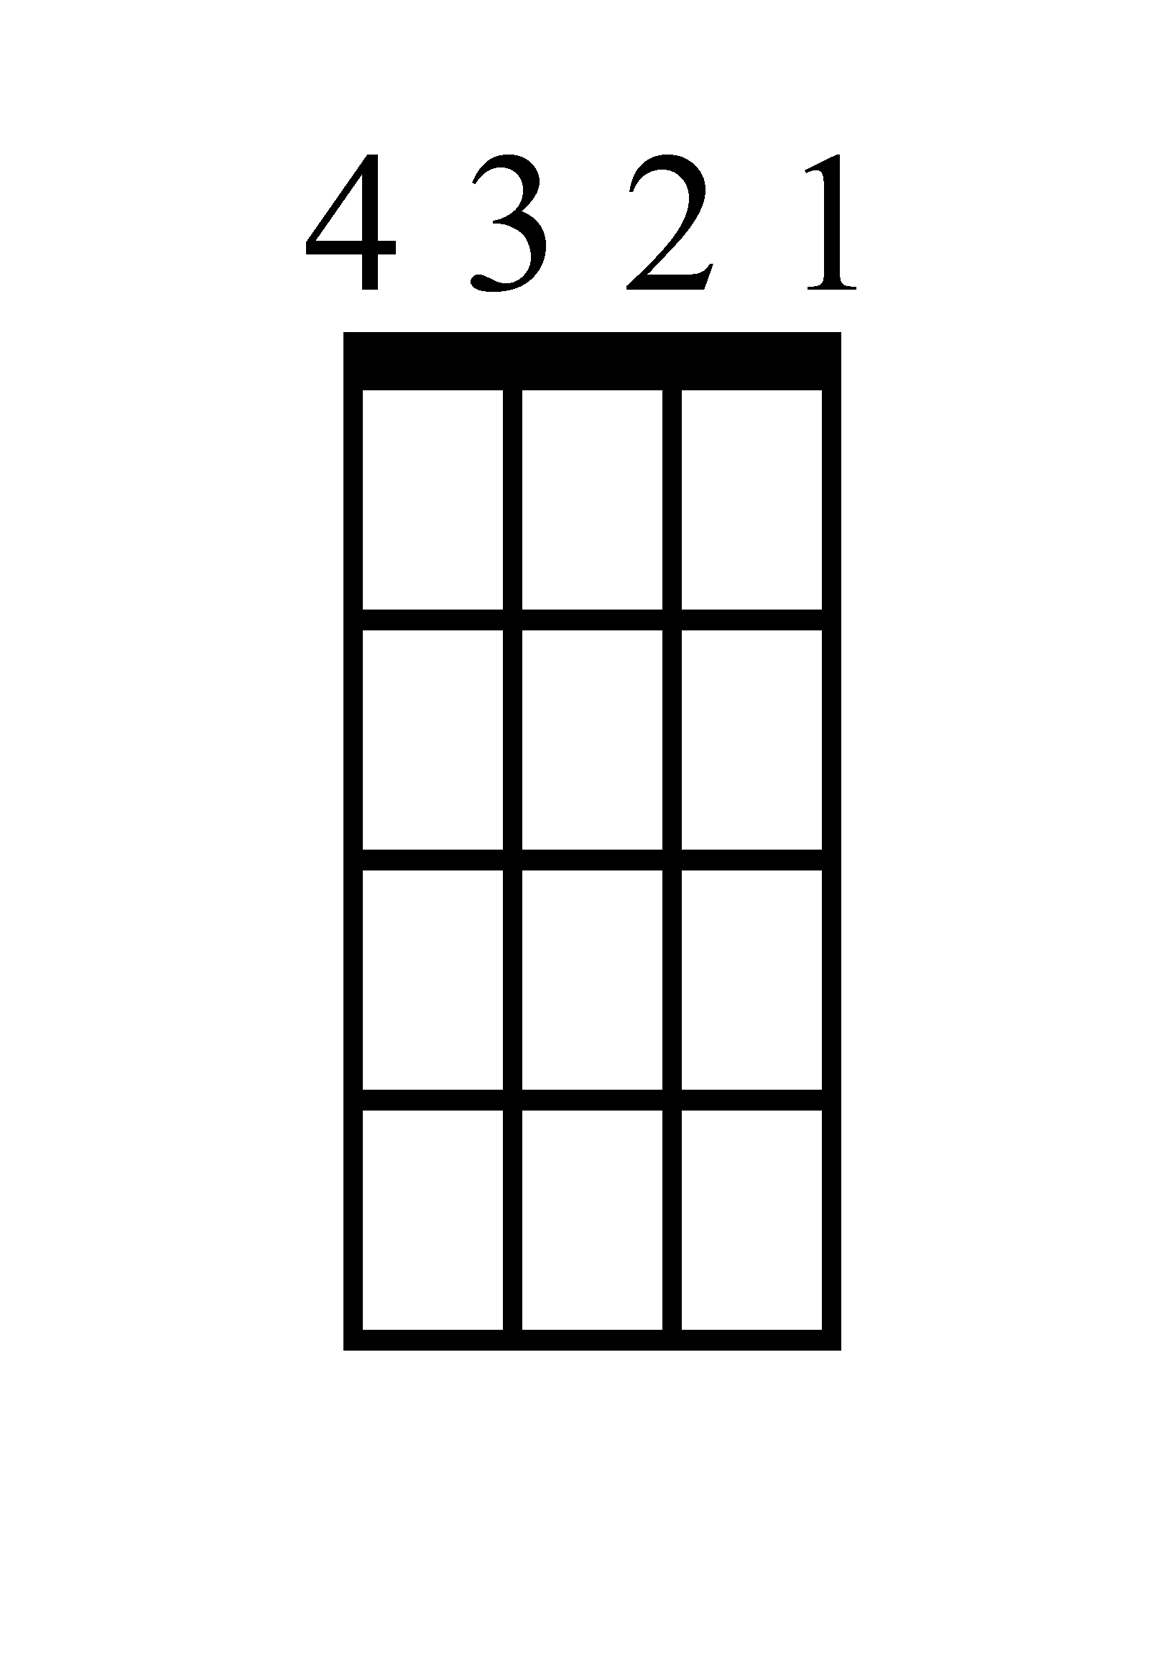
Bass Guitar
G
C
D
D

1+2+3+4+ 1+2+3+4+ 1+2+3+4+ 1+2+3+4+

Actual Bass Riff
1-------------------------------------------------------------------------------------------------------------------------------------------------------------------------------------
2-------------------------------------------------------------------------------------------------------------------------------------------------------------------------------------
3----------5---------------5-------------------------5--------------5-------------------------3---------------3-------------------------------------------------------------------
4------------------------------------------------5-----------------------------------------5-----------------------------------------5—3---------------3-------------------5----
1 + 2 + 3 + 4 + 1 + 2 + 3 + 4 + 1 + 2 + 3 + 4 + 1 + 2 + 3 + 4 +
Lorde - Royals
Ukulele Chords
D
C
G
D

1+2+3+4+ 1+2+3+4+ 1+2+3+4+ 1+2+3+4+

Chorus Uke Riff
1---------9---------------5------------------------ 1------------------3-3----7-7----------------------
2---------------------------------------------------- 2----------3-3--------------------------------------
3---------------------------------------------------- 3----------------------------------------------------
And we’ll never be royals… 4---------------------------------------------------- And baby I’ll rule… 4----------------------------------------------------

Lorde - Royals
Piano

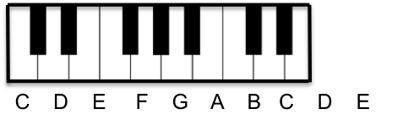
D
1+2+3+4+

D
1+2+3+4+

C
1+2+3+4+

G
1+2+3+4+

Chorus Piano Riff (just play the notes)
And we’ll never be royals…
F# D

And baby I’ll rule…
G G C C D D G
Lorde - Royals
Lyrics (Page 1)

[Verse 1]
I've never seen a diamond in the flesh
I cut my teeth on wedding rings in the movies
And I'm not proud of my address
In a torn-up town, no post code envy

[Pre-Chorus]
But every song's like
Gold teeth, Grey Goose, trippin' in the bathroom
Bloodstains, ball gowns, trashin' the hotel room
We don't care; we're driving Cadillacs in our dreams
But everybody's like
Cristal, Maybach, diamonds on your timepiece
Jet planes, islands, tigers on a gold leash
We don't care; we aren't caught up in your love affair

[Chorus]
And we'll never be royals (royals)
It don't run in our blood
That kind of luxe just ain't for us
We crave a different kind of buzz
Let me be your ruler (ruler)
You can call me queen bee
And baby I'll rule (I'll rule, I'll rule, I'll rule...)
Let me live that fantasy

Lorde - Royals
Lyrics (Page 2)

[Verse 2]
My friends and I, we've cracked the code
We count our dollars on the train to the party
And everyone who knows us knows
We're fine with this
We didn't come from money

[Pre-Chorus]
But every song's like
Gold teeth, Grey Goose, trippin' in the bathroom
Bloodstains, ball gowns, trashin' the hotel room
We don't care; we're driving Cadillacs in our dreams
But everybody's like
Cristal, Maybach, diamonds on your timepiece
Jet planes, islands, tiger's on a gold leash
We don't care; we aren't caught up in your love affair

[Chorus]
And we'll never be royals (royals)
It don't run in our blood
That kind of luxe just ain't for us
We crave a different kind of buzz
Let me be your ruler (ruler)
You can call me queen bee
And baby I'll rule (I'll rule, I'll rule, I'll rule...)
Let me live that fantasy

Lorde - Royals
Lyrics (Page 3)

[Bridge]
(Oooh ooooh ohhh)
We're bigger than we ever dreamed
And I'm in love with being queen
(Oooooh ooooh ohhhhh)
Life is great without a care
We aren't caught up in your love affair

[Chorus]
And we'll never be royals (royals)
It don't run in our blood
That kind of luxe just ain't for us
We crave a different kind of buzz
Let me be your ruler (ruler)
You can call me queen bee
And baby I'll rule (I'll rule, I'll rule, I'll rule...)
Let me live that fantasy

