Medley 1
Guitar

Am
C
G
Em

Medley 1
Bass Guitar

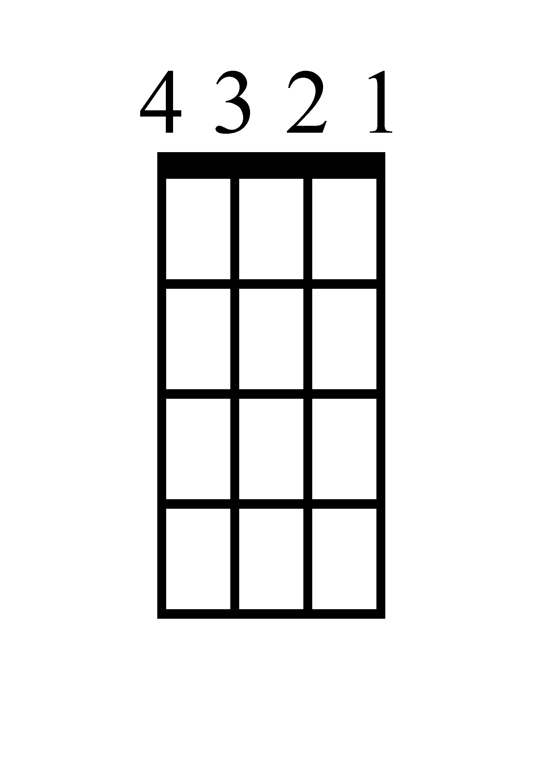
A
C
G
E

Medley 1
Ukulele

Am
C
Em
G

Medley 1
Piano

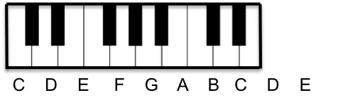
G

Am

Em

C

Halo Lyrics

Remember those walls I built
Well, baby, they're tumbling down
And they didn't even put up a fight
They didn't even make a sound

I found a way to let you win
But I never really had a doubt
Standing in the light of your halo
I got my angel now

It's like I've been awakened
Every rule I had you break it
It's the risk that I'm taking
I ain't never gonna shut you out

Everywhere I'm looking now
I'm surrounded by your embrace
Baby, I can see your halo
You know you're my saving grace

You're everything I need and more
It's written all over your face
Baby, I can feel your halo
Pray it won't fade away

I can feel your halo (halo) halo
I can see your halo (halo) halo
I can feel your halo (halo) halo
I can see your halo (halo) halo

Stay Lyrics
Not really sure how to feel about it
Something in the way you move
Makes me feel like I can't live without you
It takes me all the way
I want you to stay

Firework Lyrics
Do you ever feel like a plastic bag
Drifting thought the wind
Wanting to start again
Do you ever feel, feel so paper thin
Like a house of cards
One blow from caving in
Do you ever feel already buried deep
Six feet under scream
But no one seems to hear a thing
Do you know that there's still a chance for you
'Cause there's a spark in you
You just gotta ignite the light
And let it shine
Just own the night
Like the Fourth of July
'Cause baby you're a firework
Come on show 'em what your worth
Make 'em go "Oh, oh, oh!"
As you shoot across the sky-y-y
Baby you're a firework
Come on let your colors burst
Make 'em go "Aah, Aah, Aah!"
You're gonna leave 'em all in awe,awe, awe

Geronimo Lyrics

Can you feel it?
Now its coming back we can steal it
If we bridge this gap
I can see you
Through the curtains of the waterfall
When I lost it
Yeah you held my hand
But I tossed it
Didn't understand
You were waiting
As I dove into the waterfall

So say Geronimo!
Say Geronimo!
Say Geronimo!
Say Geronimo!
Say Geronimo!
Say Geronimo!
Say Geronimo!

Can you feel my love?
Bombs away
Bombs away
Bombs away
Can you feel my love?
Bombs away
Bombs away
Bombs away
Say Geronimo!

