Tones and I – Johnny Run Away
Guitar Chords

Verse
A
D
G
Bm

Chorus: “Johnny run away…”
A
A
D
G
Tones and I – Johnny Run Away
Bass Guitar

Verse
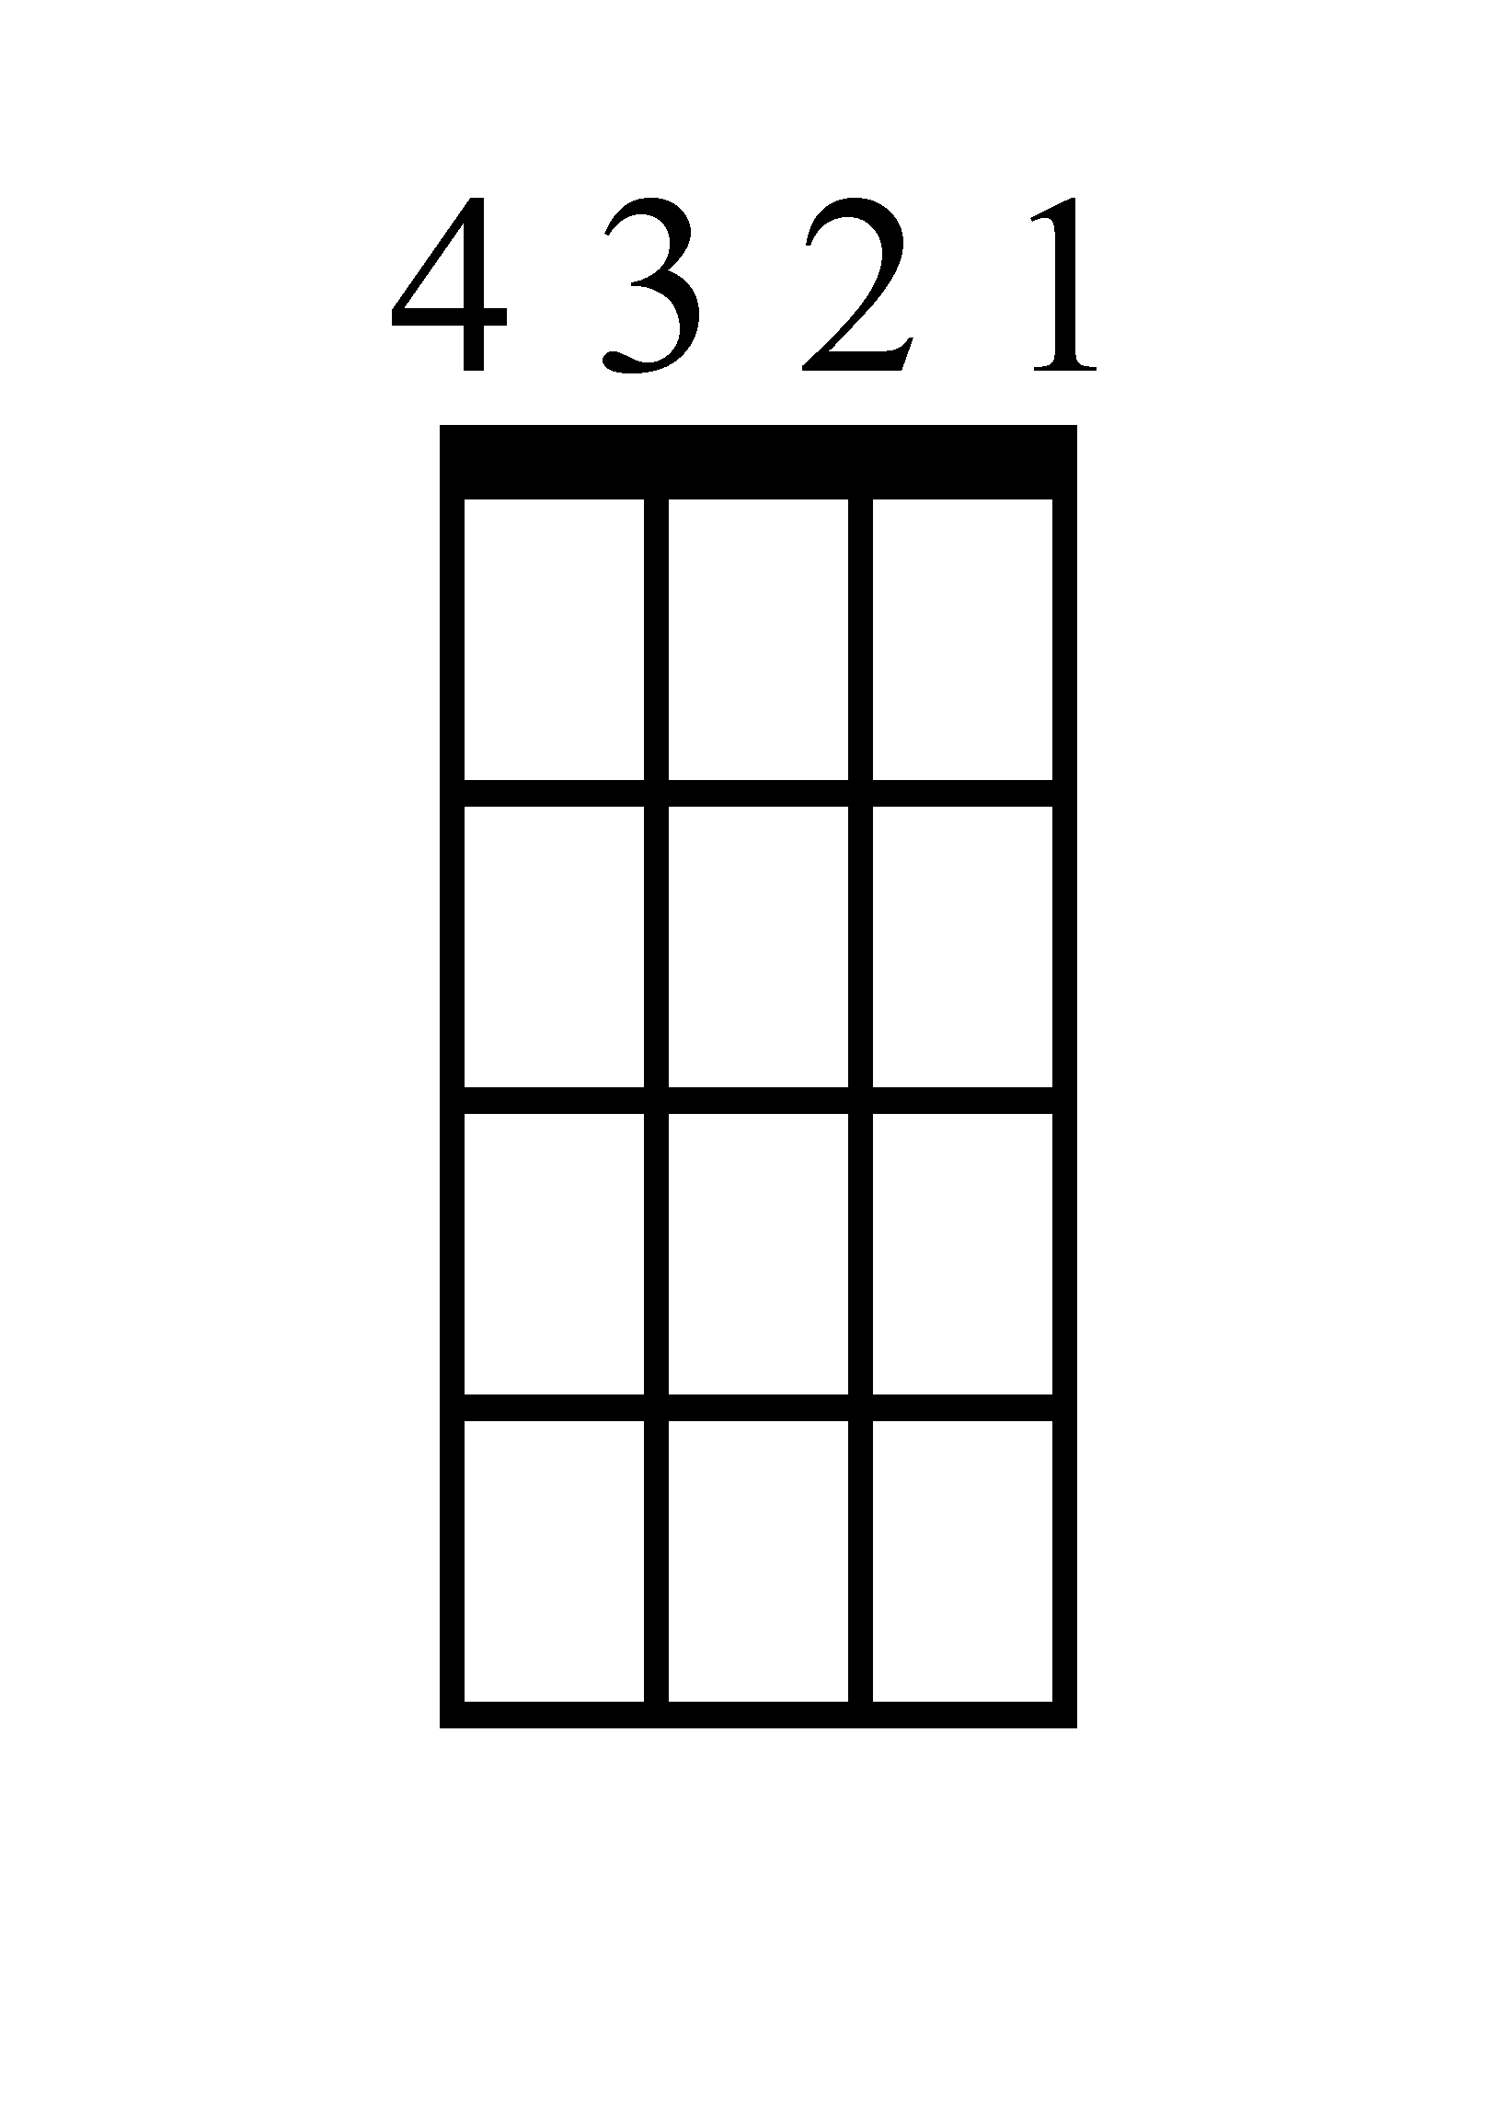
G
D
A
B

Chorus: “Johnny run away…”
B
A
A
D
G

Tones and I – Johnny Run Away
Ukulele Chords

Verse

A
Bm
D
G

Chorus: “Johnny run away…”

G
D
A
A

Tones and I – Johnny Run Away Tones and I – Johnny Run Away
Piano – Verse Piano - Chorus

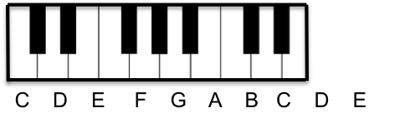
G
Bm

A
D
A
G

D

A

Tones and I – Johnny Run Away
Tones and I – Johnny Run Away
Lyrics (Page 2)

[Chorus]
Johnny run away, run away now, Johnny now
Johnny run away, run away now, Johnny now
You'll get picked on by another
Better go and run for cover, yeah
Johnny run away, run away now, Johnny now
Johnny run away, run away now, Johnny now
You'll get picked on by another
Better go and run for cover

[Verse 4]
And I don't wanna to talk about the trap, I've dreamed big
Real big since I've been on daddy's lap
Got my dreams by my side
Keep them in my pocket so that when I get the chance
I can rip it out and rock it
It's like my golden ticket, it's the reason that I’m here
Everybody has a dream, but they're frozen by fear
We won't dance in the rain, we go and run for cover
All that is to blame is getting picked on by another
So we go and find someone that will love and support us
Says they adore us, maybe fought for us
Then, we forget about ambitions and decisions have changed
I think that I was only seven when, oh

[Chorus]

[Outro]

Lyrics (Page 1)

[Verse 1]
Johnny was a young boy, he liked playing at the park
And Johnny said, "Oh, dad can you take me now?"
Johnny was young, never hurt no one, too early for that
He was at the park, he met a boy named Jimmy
He's a cutie and he chose him, oh

[Verse 2]
Take my heart, take my soul, share my crayons, share my goals
His daddy walked by with a sigh, said, "Johnny, sit by my side
I'm gonna give you the best advice you've ever heard in your life
See that boy named Jimmy, yeah, he's a cutie
But no, no, Johnny no, no, no, ah, ah, oh"

[Chorus]
Johnny run away, run away now, Johnny now
Johnny run away, run away now, Johnny now
You'll get picked on by another
Better go and run for cover, yeah
Johnny run away, run away now, Johnny now
Johnny run away, run away now, Johnny now
You'll get picked on by another
Better go and run for cover

[Verse 3]
Johnny started high school at the front of the bus
Some boys yelled, "Oh man, come sit with us"
Johnny found a seat with a boy named Pete and felt it again
As he was trying to play pretend, the feelings came rushing in
And he thought

