Amy Shark – I Said Hi
Guitar
Em
C
G
D
Intro/Verse/Chorus

Intro/1st Verse 1+2+3+4+ 1+2+3+4+ 1+2+3+4+ 1+2+3+4+
Verses/Chorus 1+2+3+4+ 1+2+3+4+ 1+2+3+4+ 1+2+3+4+
Em
D
G
C
Bridge

First bit 1+2+3+4+ 1+2+3+4+ 1+2+3+4+ 1+2+3+4+
Second Bit 1+2+3+4+ 1+2+3+4+ 1+2+3+4+ 1+2+3+4+

Amy Shark – I Said Hi
Bass Guitar

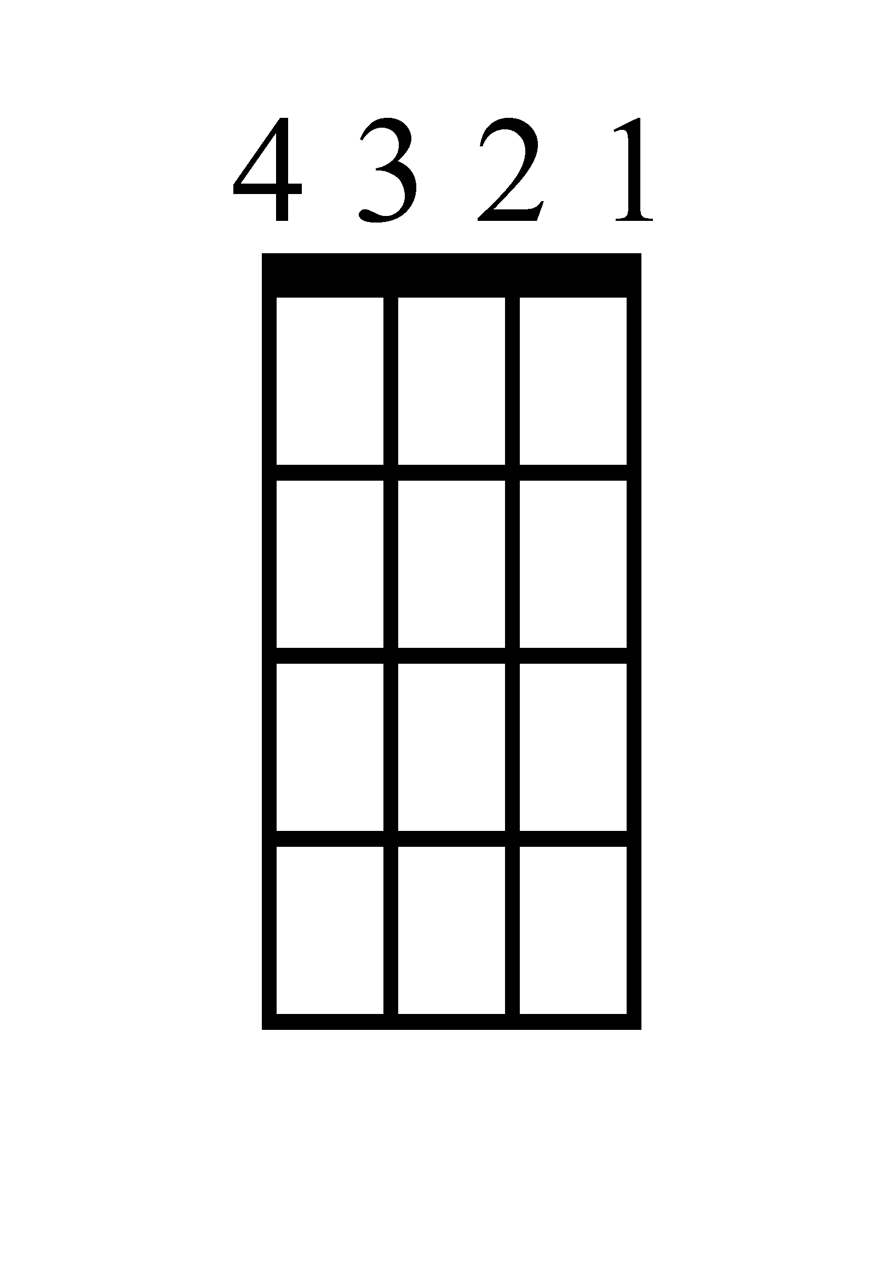
Intro/Verse/Chorus
D
C
G
Em

Intro/1st Verse 1+2+3+4+ 1+2+3+4+ 1+2+3+4+ 1+2+3+4+
Verses/Chorus 1+2+3+4+ 1+2+3+4+ 1+2+3+4+ 1+2+3+4+
D
C
Em
G

Bridge

First bit 1+2+3+4+ 1+2+3+4+ 1+2+3+4+ 1+2+3+4+
Second Bit 1+2+3+4+ 1+2+3+4+ 1+2+3+4+ 1+2+3+4+
Amy Shark – I Said Hi
Ukulele
G
C
D
Em
Intro/Verse/Chorus

Intro/1st Verse 1+2+3+4+ 1+2+3+4+ 1+2+3+4+ 1+2+3+4+
Verses/Chorus 1+2+3+4+ 1+2+3+4+ 1+2+3+4+ 1+2+3+4+
Em
D
G
C

Bridge

First bit 1+2+3+4+ 1+2+3+4+ 1+2+3+4+ 1+2+3+4+
Second Bit 1+2+3+4+ 1+2+3+4+ 1+2+3+4+ 1+2+3+4
Amy Shark – I Said Hi
Em C G D
Intro/1st Verse 1+2+3+4+ 1+2+3+4+ 1+2+3+4+ 1+2+3+4+
Verses/Chorus 1+2+3+4+ 1+2+3+4+ 1+2+3+4+ 1+2+3+4+

Piano (Page 1)

Intro/Verse/Chorus
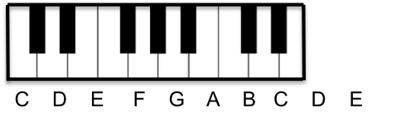
Em

C

G

D

Amy Shark – I Said Hi
Em D G C
Intro/1st Verse 1+2+3+4+ 1+2+3+4+ 1+2+3+4+ 1+2+3+4+
Verses/Chorus 1+2+3+4+ 1+2+3+4+ 1+2+3+4+ 1+2+3+4+

Piano (Page 2)
Bridge
Em

D

G

C

Amy Shark – I Said Hi
Lyrics (Page 1)

Verse 1
I stand in the corner like a tired boxer
One hand on my cheekbone, one hand on the rope
And all my veins pump blood into my throat
So I can hit the note, go do it all again

Chorus 1
Tell 'em all I said hi (hi) x2

Verse 2
And I lay half awake, thinking what's it's gonna take
For my mama to arrive, so sick and paralyzed
And I chew my bone on the left side of my mouth
Wonder when I'll spit it out, yeah, I'm just getting started

Chorus 2
Tell 'em all I said hi, hope you've been well
You've been asleep while I've been in hell
Tell 'em all I said hi, have a nice day
I'll be just fine, don't worry 'bout me
Tell 'em all I said hi (hi)
Tell 'em all I said hi (hi)

Verse 3
I stand in the corner like a tired boxer
One hand on my cheekbone, one hand on the rope
And all my veins pump blood into my throat
So I can hit the note, go do it all again
Amy Shark – I Said Hi
Lyrics (Page 2)

Chorus 3
Tell 'em all I said hi, hope you've been well
You've been asleep while I've been in hell
Tell 'em all I said hi, have a nice day
I'll be just fine, don't worry 'bout me
Tell 'em all I said hi (hi)
Tell 'em all I said hi (hi)

Bridge
Lying on my side, watching time fly by
And I bet the whole world thought that I would give up today
Oh, I'm lying on my side, watching time fly by
And I bet the whole world thought that I would give up today
Lying on my side, watching time fly by
And I bet the whole world thought that I would give up today
Lying on my side, watching time fly by
And I bet the whole world thought that I would give up
Yeah, I bet the whole world thought that I would give up

Chorus 4
Tell 'em all I said hi, hope you've been well
You've been asleep while I've been in hell
Tell 'em all I said hi, have a nice day
I'll be just fine, don't worry 'bout me
Tell 'em all I said hi (hi)
Tell 'em all I said hi

Amy Shark – I Said Hi
Outline

Intro/Verse 1: |Em / |C / |G / |D / | x3

Chorus 1: |Em / / |C / / |G / / |D / / | x2

Verse 2: |Em / / |C / / |G / / |D / / | x2

Only play the D ONCE in the bit between Verse 2 and Chorus 2!

Chorus 2: |Em / / |C / / / |G / / |D / / / | x4

Verse 3: |Em / / |C / / |G / / |D / / | x2

Chorus 3: |Em / / |C / / / |G / / |D / / / | x4

Bridge (guitar/keys): |Em / / |D / / / |G / / |C / / / | x2

Bridge (whole band): |Em / / |D / / / |G / / |C / / / | x2

Bridge (just drums): |Em / / |D / / / |G / / |C / / / | x1

Bridge (drums/bass): |Em / / |D / / / |G / / |C / / / | x1

Only play the D ONCE in the bit between Bridge and Chorus 4!

Chorus 4: |Em / / |C / / / |G / / |D / / / | x4

