Pharrell Williams - Happy
Guitar Page One

Verse/Bridge
Em

Guitar Riff
1-------------0-------------3-------------5-------------3-------------7-------------7-------------5------------3-----------0
2---------------------------------------------------------------------------------------------------------------------------------
3---------------------------------------------------------------------------------------------------------------------------------
1+2+3+4+
4---------------------------------------------------------------------------------------------------------------------------------
5---------------------------------------------------------------------------------------------------------------------------------
6---------------------------------------------------------------------------------------------------------------------------------

Pharrell Williams - Happy
Guitar Page Two

Chorus
Bm
E
Bm
C

1+2+3+4+ 1+2+3+4+ 1+2+3+4+ 1+2+3+4+

Pharrell Williams - Happy
Bass Page 1

Verse/Bridge
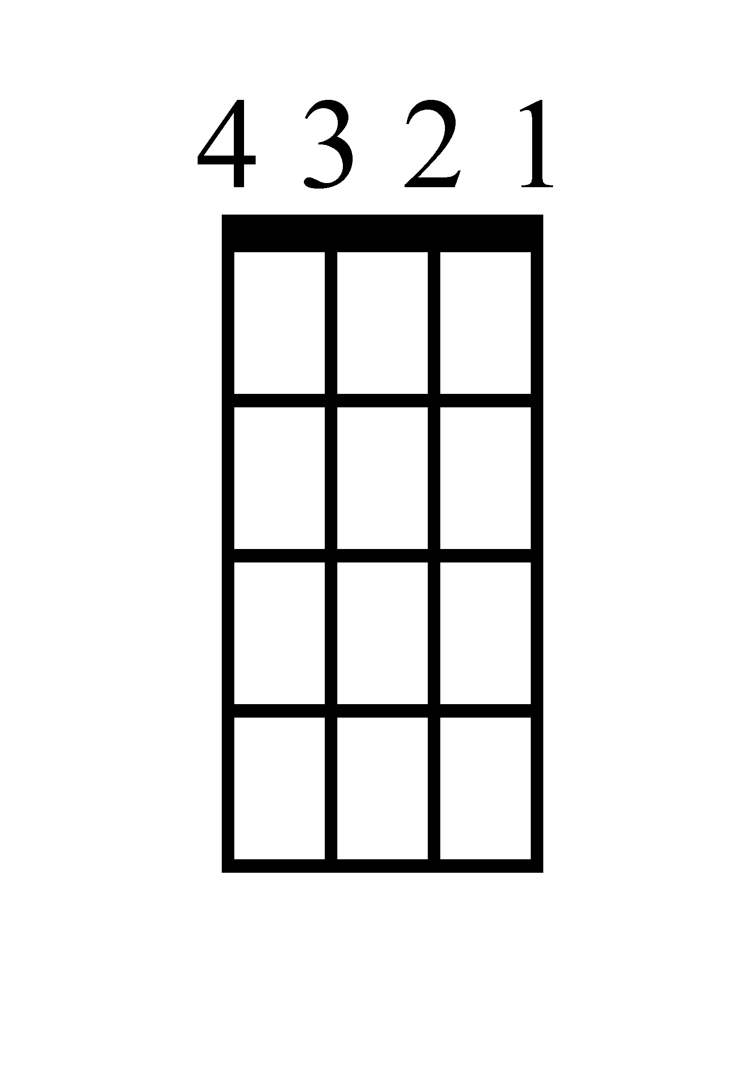
Em

Bass Riff
1+2+3+4+
1---------------------------------------------------------------------------------------------------------------------------------
2---------------------------------------------------------------------------------------------------------------------------------
3---------------------------------------------------------------------------------------------------------------------------------
4-------------0-------------3-------------5-------------3-------------7-------------7-------------5------------3-----------0

Pharrell Williams - Happy
Bass Page 2

Chorus
E
B
B
C

1+2+3+4+ 1+2+3+4+ 1+2+3+4+ 1+2+3+4+

Pharrell Williams - Happy
Piano

Verse/Bridge
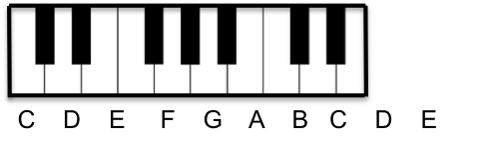
Em
1+2+3+4+

Chorus

C
1+2+3+4+

Bm
1+2+3+4+

Bm
1+2+3+4+

E
1+2+3+4+

Pharrell Williams - Happy
Lyrics (Page 1)

[Verse 1]
It might seem crazy what I'm 'bout to say
Sunshine she's here, you can take a break
I'm a hot air balloon that could go to space
With the air, like I don't care, baby, by the way

[Chorus]
Because I'm happy
Clap along if you feel like a room without a roof
Because I'm happy
Clap along if you feel like happiness is the truth
Because I'm happy
Clap along if you know what happiness is to you
Because I'm happy
Clap along if you feel like that's what you wanna do

[Verse 2]
Here come bad news, talking this and that (Yeah!)
Well, give me all you got, don't hold it back (Yeah!)
Well, I should probably warn ya, I'll be just fine (Yeah!)
No offense to you, don’t waste your time, here's why

[Chorus]
Pharrell Williams - Happy
Lyrics (Page 2)

[Bridge]
Bring me down
Can't nothing bring me down
My level's too high to bring me down
Can't nothing bring me down, I said
Bring me down
Can't nothing bring me down
My level's too high to bring me down
Can't nothing bring me down, I said

[Chorus]

[Bridge]
Bring me down
Can't nothing bring me down
My level's too high to bring me down
Can't nothing bring me down, I said...

[Chorus] x2

