Alan Walker – Ghost Town
Guitar

Chorus

G
Am
Em
C

Intro/Verse 1+2+3+4+ 1+2+3+4+ 1+2+3+4+ 1+2+3+4+
Chorus 1+2+3+4+ 1+2+3+4+ 1+2+3+4+ 1+2+3+4+

Alan Walker – Ghost Town
Bass Guitar

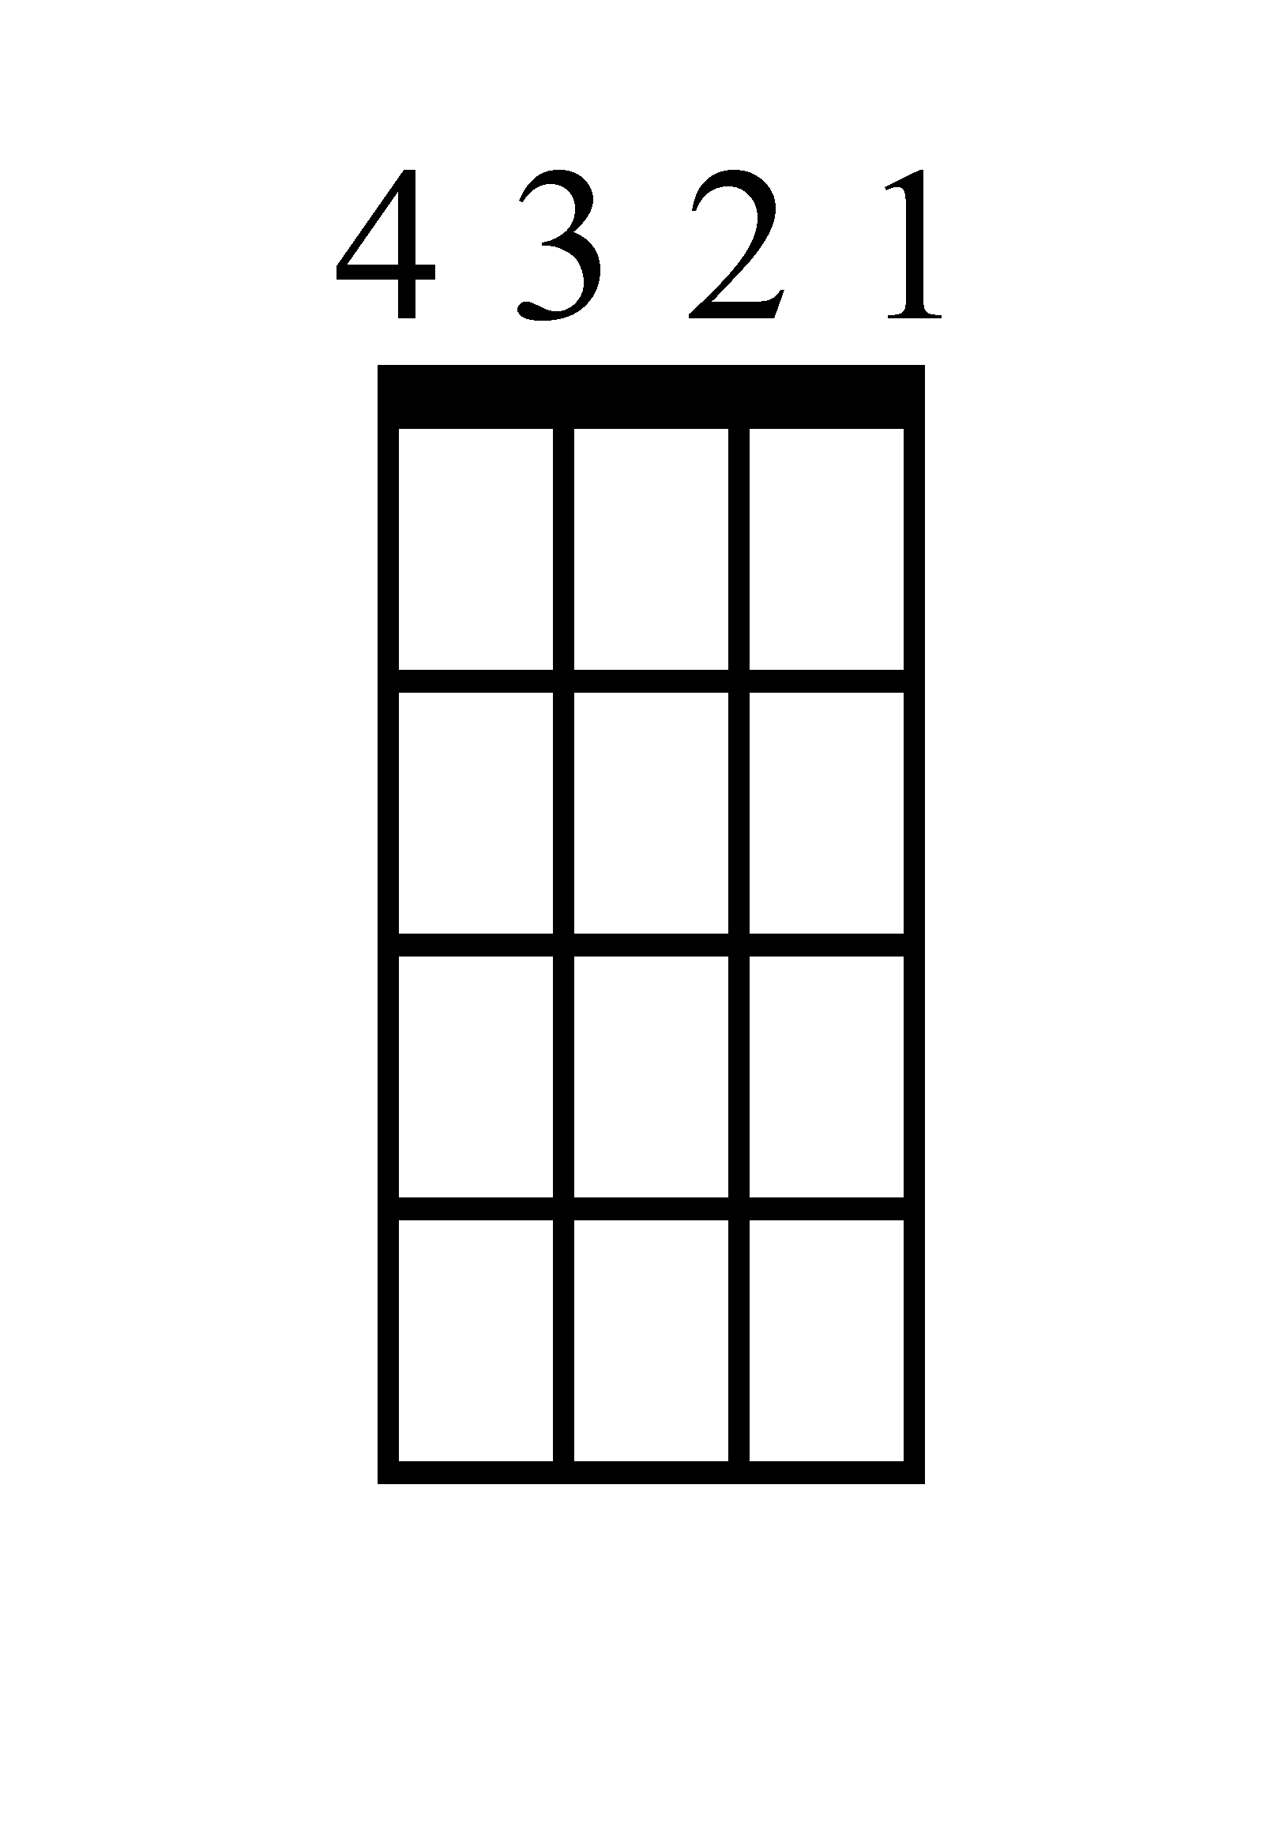
Am
G
Em
C

Intro/Verse 1+2+3+4+ 1+2+3+4+ 1+2+3+4+ 1+2+3+4+
Chorus 1+2+3+4+ 1+2+3+4+ 1+2+3+4+ 1+2+3+4+

Alan Walker – Ghost Town
Ukulele

C
Em
G
Am

Intro/Verse 1+2+3+4+ 1+2+3+4+ 1+2+3+4+ 1+2+3+4+
Chorus 1+2+3+4+ 1+2+3+4+ 1+2+3+4+ 1+2+3+4+

Alan Walker – Ghost Town
Piano

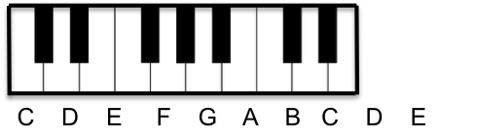
C
V. 1+2+3+4+
C. 1+2+3+4+

Em
V. 1+2+3+4+
C. 1+2+3+4+

G
V. 1+2+3+4+
C. 1+2+3+4+

Am
V. 1+2+3+4+
C. 1+2+3+4+

