Vance Joy – Fire and the Flood
Guitar

Intro/Verse
G x4: “I was only walking through your neighbourhood”

G x2: “Anywhere I go there you are…”
C x2

Pre-Chorus: “There you are, there you are…”
D x2
G x1
C x1

Chorus: “You’re the fire and the flood…”
D x1
G x1
C x1
Em x1

Vance Joy – Fire and the Flood
Bass Guitar

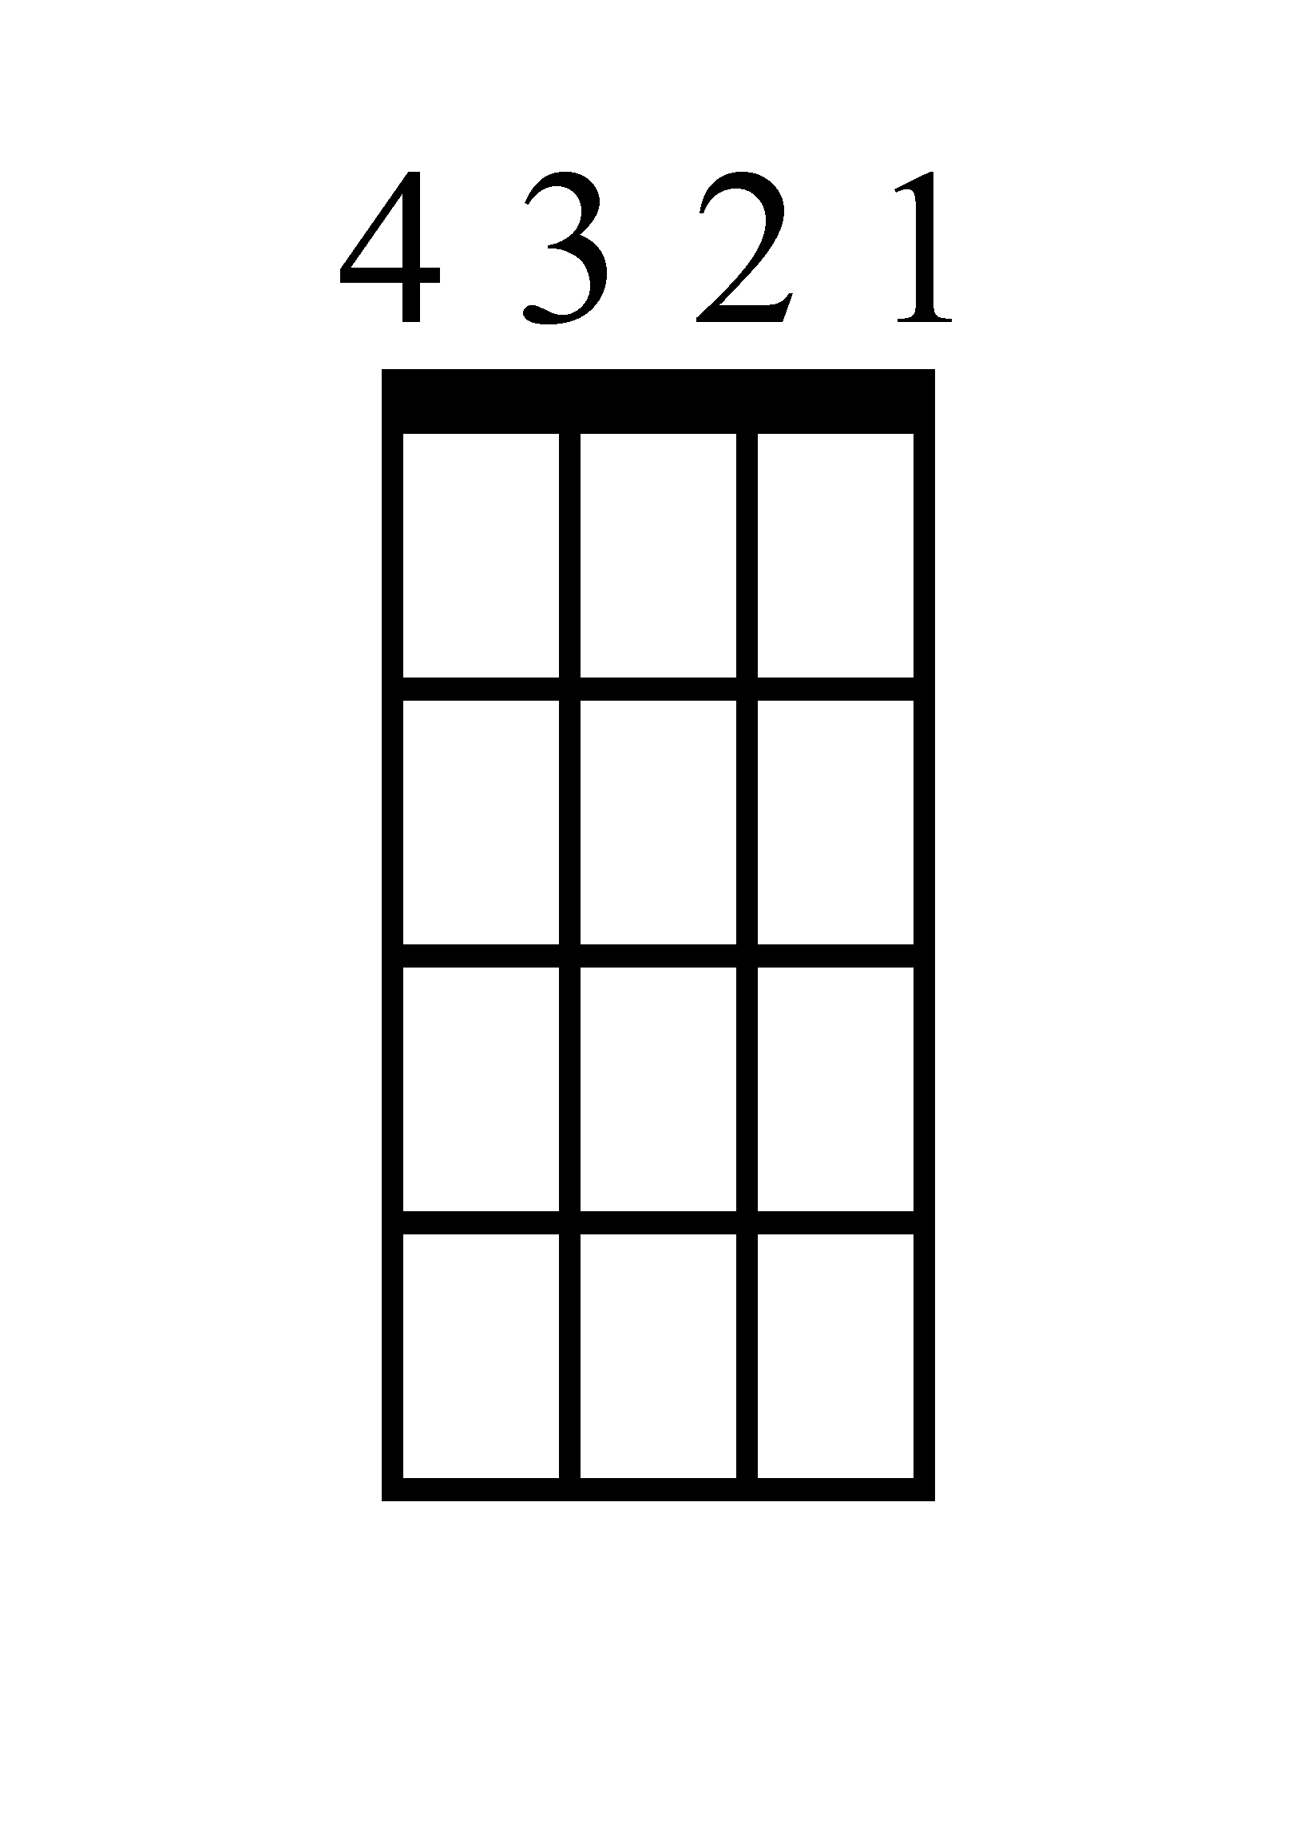
Intro/Verse
G x4: “I was only walking through your neighbourhood”

G x2: “Anywhere I go there you are…”

C x2

Pre-Chorus: “There you are, there you are…”
G x1
D x2
C x1

Chorus: “You’re the fire and the flood…”
D x1
G x1
E x1
C x1
Vance Joy – Fire and the Flood
Ukulele

Intro/Verse
G x4: “I was only walking through your neighbourhood”

G x2: “Anywhere I go there you are…”

C x2

Pre-Chorus: “There you are, there you are…”
D x2
G x1
C x1

Chorus: “You’re the fire and the flood…”
Em x1
G x1
C x1
D x2
Vance Joy – Fire and the Flood
Piano (Page 1)

Intro/Verse: “I was only walking through your neighbourhood”
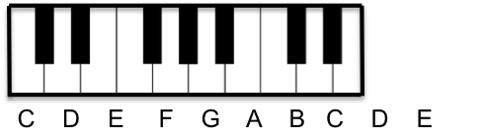
G x4

“Anywhere I go there you are…”
C x2

G x2

Pre-Chorus: “There you are, there you are…”
C x1

G x1

D x2

Vance Joy – Fire and the Flood
Piano (Page 2)

Chorus: “You’re the fire and the flood…”

Em x1

C x1

G x1

D x1

Vance Joy – Fire and the Flood
Lyrics (Page 1)

Verse 1
I was only walking through your neighborhood
Saw your light on, honey; in the cold I stood
Anywhere I go there you are
Anywhere I go there you are

Verse 2
I been getting used to waking up with you
I been getting used to waking up here
Anywhere I go there you are
Anywhere I go there you are

Pre-Chorus 1
There you are, there you are

Chorus 1
You're the fire and the flood
And I'll always feel you in my blood
Everything is fine
When your head's resting next to mine
Next to mine
You're the fire and the flood

Verse 3
Since we met I feel a lightness in my step
You're miles away but I still feel you
Anywhere I go there you are
Anywhere I go there you are
Verse 4
Late at night when you can't fall asleep
I'll be lying right beside you counting sheep
Anywhere I go there you are
Anywhere I go there you are

Pre-Chorus 2
There you are, there you are

Chorus 2
You're the fire and the flood
And I'll always feel you in my blood
Everything is fine
When your head's resting next to mine
Next to mine
You're the fire and the flood

Bridge
Now listen here she said
Boy when you know you'll know
And I know

Chorus 3
You're the fire and the flood
And I'll always feel you in my blood
Everything is fine
When your head's resting next to mine
Next to mine
You're the fire and the flood

