Halsey, Benny Blanco & Khalid - Eastside
Guitar Chords

D
C
Em
G
D

1+2+3+4+ 1+2+ 3+4+ 1+2+3+4+1+2+ 3+4+

Guitar Riff
1--------3---------------------------------------------2---------------------------------------------7-------------------------0-----------------------0---------------------2---------------
2------------------------------------------------------------------------------------------------------------------------------------------------------------------------------------------------
3------------------------------------------------------------------------------------------------------------------------------------------------------------------------------------------------
4------------------------------------------------------------------------------------------------------------------------------------------------------------------------------------------------
5------------------------------------------------------------------------------------------------------------------------------------------------------------------------------------------------
6------------------------------------------------------------------------------------------------------------------------------------------------------------------------------------------------
Halsey, Benny Blanco & Khalid - Eastside
Bass Guitar

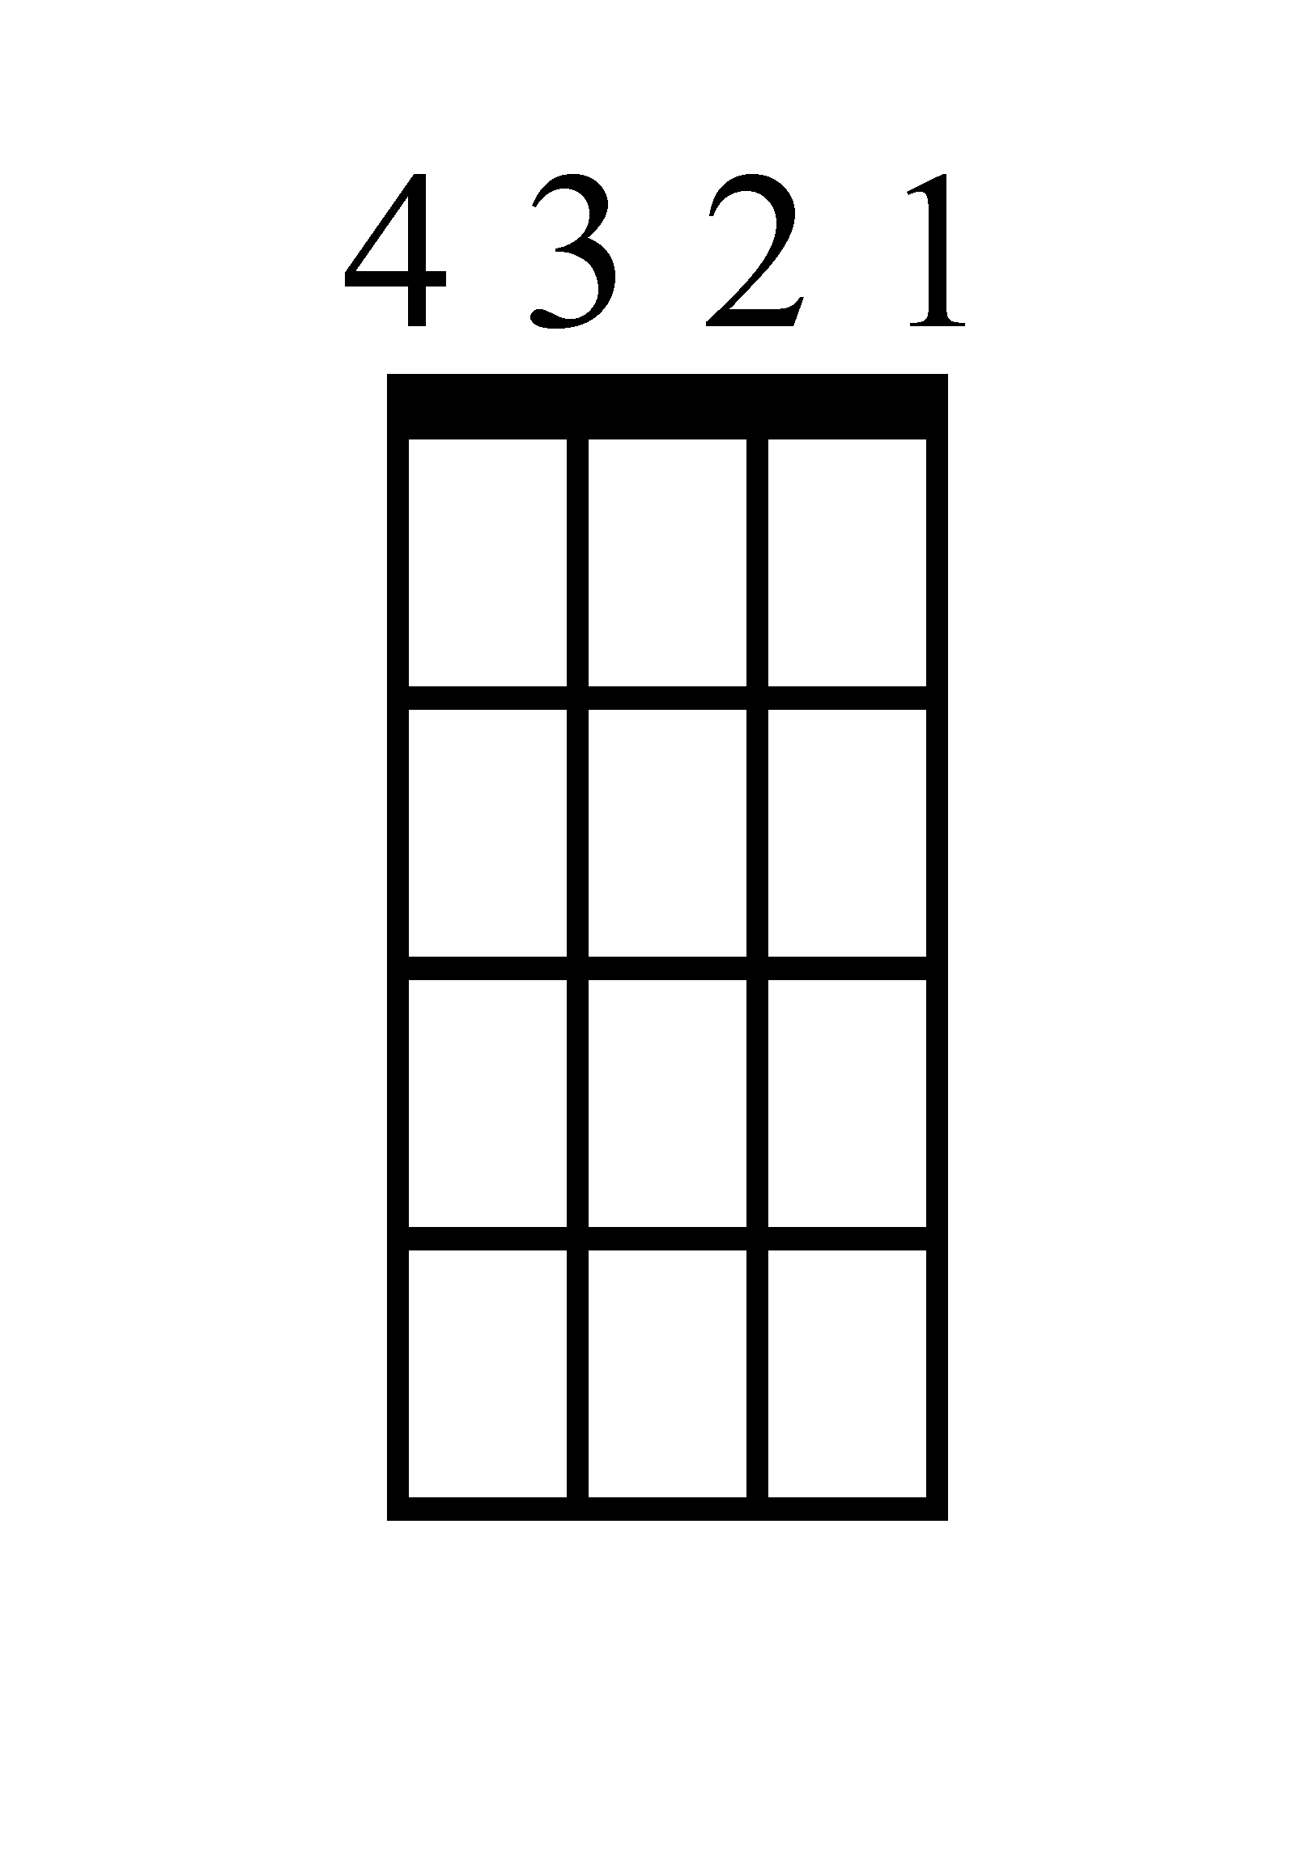
Em
D
C
G
D

1+2+3+4+ 1+2+ 3+4+ 1+2+3+4+1+2+ 3+4+

Halsey, Benny Blanco & Khalid - Eastside
Ukulele Chords
D
C
G
Em
D

1+2+3+4+ 1+2+ 3+4+ 1+2+3+4+1+2+ 3+4+

Ukulele Riff
1------------------------------------------------------------------------------------------------------------------------------------------------------------------------------------------------
2--------3---------------------------------------------2--------------------------------------7----------------------0-----------------------0----------------------------2------------------
3------------------------------------------------------------------------------------------------------------------------------------------------------------------------------------------------
4------------------------------------------------------------------------------------------------------------------------------------------------------------------------------------------------

Halsey, Benny Blanco & Khalid - Eastside
Piano

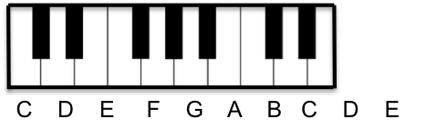
Em
1+2+3+4+

D
1+2+

G
3+4+

C
1+2+3+4+1+2+

D
3+4+

Halsey, Benny Blanco & Khalid - Eastside
Lyrics (Page 1)

Verse 1
When I was young, I fell in love
We used to hold hands, man, that was enough (Yeah)
Then we grew up, started the jump
Used to high 5 near the light on the back of the bus (Yeah)
I know your daddy didn't like me much
And he didn't believe me when I said you were the one
Oh, every day, she found a way out of the window to sneak out late

Pre-Chorus 1
She used to meet me on the Eastside
In the city where the sun don't set
And every day, you know that we'd ride
Through the backstreets in a blue Corvette
Baby, you know I just wanna leave tonight
We can go anywhere we want
Drive down to the coast, jump in the sea
Just take my hand and come with me, yeah

Chorus 1
We can do anything if we put our minds to it
Take your old life, then you put a line through it
My love is yours if you're willing to take it
Give me your heart 'cause I ain't gonna break it
So come away, starting today
Start a new life together in a different place
We know that love is how all these ideas came to be
So baby, run away with me

Halsey, Benny Blanco & Khalid - Eastside
Lyrics (Page 2)

Verse 2
17, and we got a dream to have a family
A house, and everything in between
And then, oh, suddenly, we turned 23
And now we got pressure for taking our life more seriously
We got our dead-end jobs and got bills to pay
Our old friends are now our enemies
And now I, I'm thinking back to when I was young
Back to the day when I was falling in love

Pre-Chorus 2
He used to meet me on the Eastside
In the city where the sun don't set
And every day, you know where we'd ride
Through the backstreets in a blue Corvette
And baby, you know I just wanna leave tonight
We can go anywhere we want
Drive down to the coast, jump in the sea
Just take my hand and come with me, singing

Chorus 3
We can do anything if we put our minds to it
Take your old life, then you put a line through it
My love is yours if you're willing to take it
Give me your heart 'cause I ain't gonna break it
So come away, starting today
To start a new life together in a different place
We know that love is how all these ideas came to be
So baby, run away with me
Halsey, Benny Blanco & Khalid - Eastside
Lyrics (Page 3)

Bridge
Run away now, run away now
Run away now
Run away now, run away now
Run away now

Outro
He used to meet me on the Eastside
She used to meet me on the Eastside
He used to meet me on the Eastside
She used to meet me on the Eastside
In the city where the sun don't set

