Guy Sebastian - Choir
Guitar Chords
Dm
C
Bb
F

Guy Sebastian - Choir
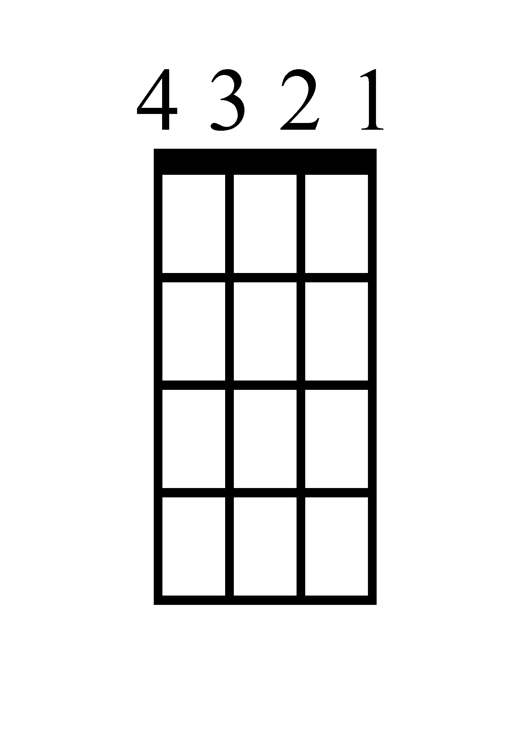
Bass Guitar
F
C
D
Bb

Guy Sebastian - Choir
Ukulele Chords

Dm
C
Bb
F

Guy Sebastian - Choir
Piano


F

Bb

Dm

C

Guy Sebastian - Choir
Lyrics (Page 1)

[Verse 1]
I know it's weird to say this
But I've been thinking 'bout it lately
Reminiscing about us in Vegas
Drinking like we're famous
Man, those days were crazy
But your book ran of pages
And now I wish I never waited
To tell you out of all the moments in my life
The ones I got to share with you
Were probably my favourite

[Pre-Chorus]
I know you're looking down on us
Yeah, I'm missing you bro
I hope you're proud of us
At least I know you made it home
And I know you're not alone

[Chorus]
'Cause now you're singing with a choir
Now you're dancing with a crew
You ain't doing this solo
We all ridin' with you
No one can put out your fire
Nobody filling your shoes
'Cause now you're singing with a choir
We all ridin' with you
Yeah, yeah

Guy Sebastian - Choir
Lyrics (Page 2)

[Verse 2]
Yeah, yeah, we fill up all our days with
Workin' and grindin' just to make ends meet
Too busy to call, we'll catch up next week
And then it gets to next week
And we say maybe next week
And then before you know, we all feeling old
Asking ourselves
"Where did my friends go?"
So don't wait till they go home

[Chorus]
'Cause now you're singing with a choir
Now you're dancing with a crew
You ain't doing this solo
We all ridin' with you
No one can put out your fire
Nobody filling your shoes
'Cause now you're singing with a choir
We all ridin' with you, Yeah, yeah

[Bridge]
Someday, I know, my friend
I'm gonna see you again
And when I do, you better have a part for me
You sing the melody and I'll take the harmony
'Cause we ain't done making music yet
We got some more sound checks
And this time we gonna have about a million voices
Singing, dancing
Party in your mansion
Guy Sebastian - Choir
Lyrics (Page 3)

[Chorus]
'Cause now you're singing with a choir
Now you're dancing with a crew (Dancing with a crew)
You ain't doing this solo (Solo)
We all ridin' with you
No one can put out your fire
Nobody filling your shoes (Hey)
'Cause now you're singing with a choir
We all ridin' with you
Yeah, yeah

[Outro]
We all ridin' with you
Yeah, yeah
We all ridin' with you
Yeah, yeah
We all ridin' with you
With you
Yeah, yeah
We all ridin' with you
We all ridin' with you
We all ridin' with you
With you
Yeah, yeah

