Billie Eilish - Bellyache
Guitar

Em
Em
C
Am

Verse 1+2+3+4+ 1+2+3+4+ 1+2+3+4+ 1+2+3+4+
Chorus 1+2+3+4+ 1+2+3+4+ 1+2+3+4+ 1+2+3+4+

Billie Eilish - Bellyache
Bass

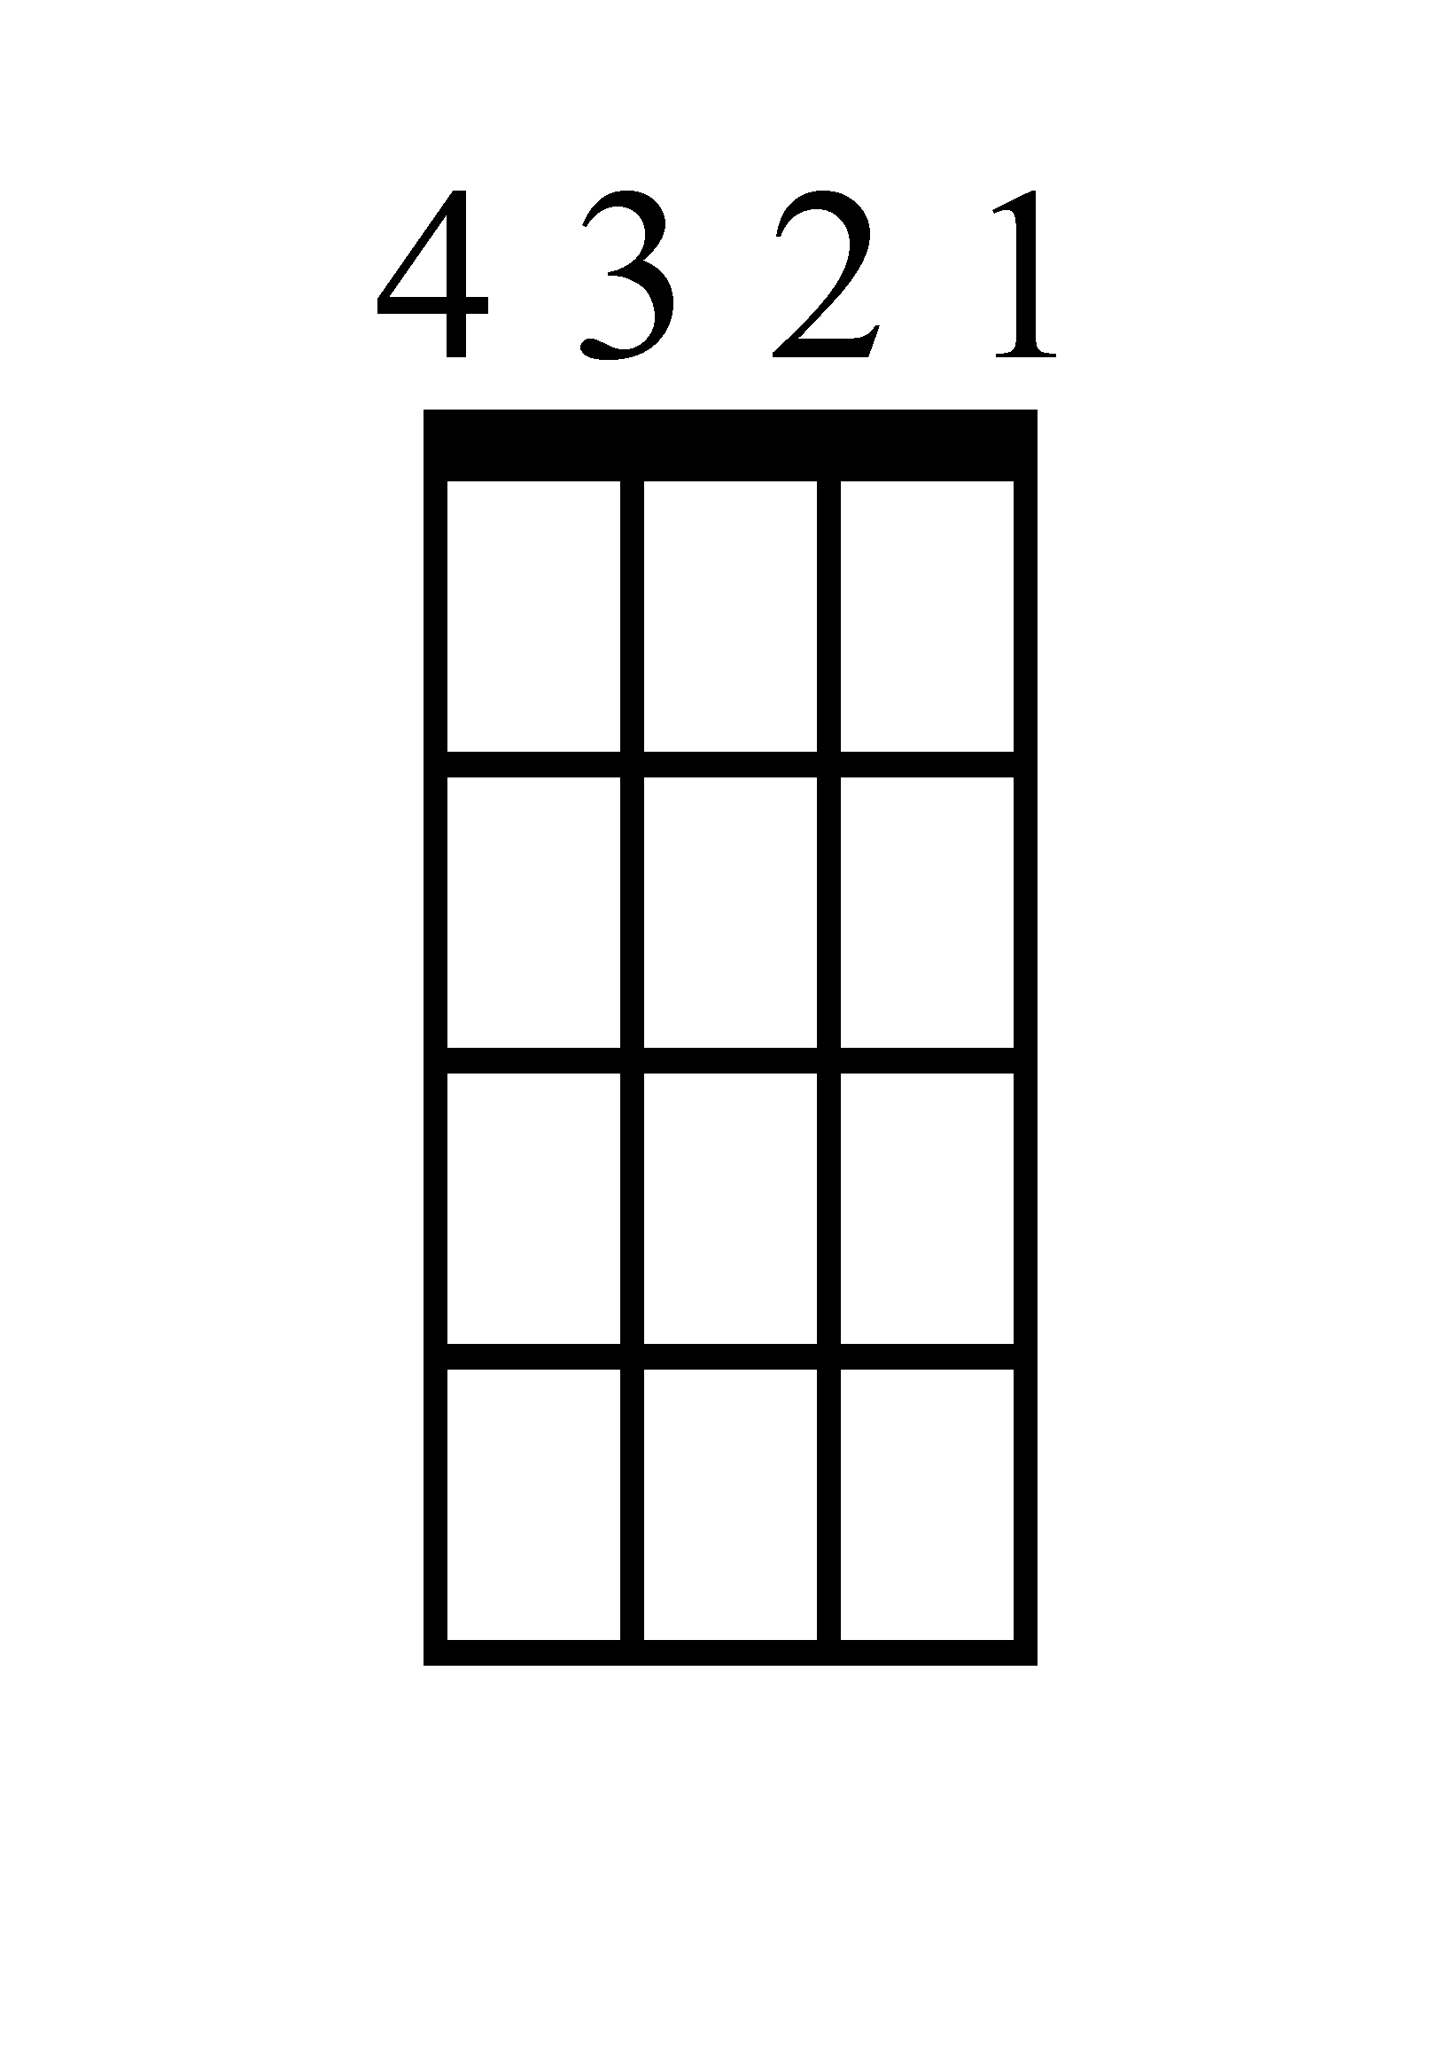
Em
Em
Am
C

Verse 1+2+3+4+ 1+2+3+4+ 1+2+3+4+ 1+2+3+4+
Chorus 1+2+3+4+ 1+2+3+4+ 1+2+3+4+ 1+2+3+4+

Billie Eilish - Bellyache
Ukulele
Am
C
Em
Em

Verse 1+2+3+4+ 1+2+3+4+ 1+2+3+4+ 1+2+3+4+
Chorus 1+2+3+4+ 1+2+3+4+ 1+2+3+4+ 1+2+3+4+

Billie Eilish - Bellyache
Piano

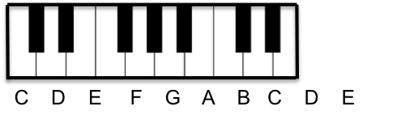
C
V. 1+2+3+4+
C. 1+2+3+4+

Am
V. 1+2+3+4+
C. 1+2+3+4+

Em
V. 1+2+3+4+
C. 1+2+3+4+

Em
V. 1+2+3+4+
C. 1+2+3+4+

Billie Eilish - Bellyache
Lyrics (Page 1)

[Intro]
Mind
Mind

[Verse 1]
Sittin' all alone
Mouth full of gum
In the driveway
My friends aren't far
In the back of my car
Lay their bodies

[Pre-Chorus]
Where's my mind?
Where's my mind?

[Verse 2]
They'll be here pretty soon
Lookin' through my room
For the money
I'm bitin' my nails
I'm too young to go to jail
It's kinda funny

[Pre-Chorus]
Where's my mind?
Where's my mind?
Where's my mind?
Where's my mind?
Billie Eilish - Bellyache
Lyrics (Page 2)

[Chorus]
Maybe it's in the gutter
Where I left my lover
What an expensive fake
My V is for Vendetta
Thought that I'd feel better
But now I got a bellyache
(Mind)

[Verse 3]
Everything I do
The way I wear my noose
Like a necklace
I wanna make 'em scared
Like I could be anywhere
Like I'm reckless

[Pre-Chorus]
I lost my mind
I don't mind
Where's my mind?
Where's my mind?

Billie Eilish - Bellyache
Lyrics (Page 3)

[Chorus]
Maybe it's in the gutter
Where I left my lover
What an expensive fake
My V is for Vendetta
Thought that I'd feel better
But now I got a bellyache
(Bellyache, bellyache, bellyache, bellyache
Bellyache, bellyache)
Maybe it's in the gutter
Where I left my lover
What an expensive fake
My V is for Vendetta
Thought that I'd feel better
But now I got a bellyache

